Qanuikkat Siqinirmiut? Southern Quebec Inuit Health Survey
Qualitative Research Report

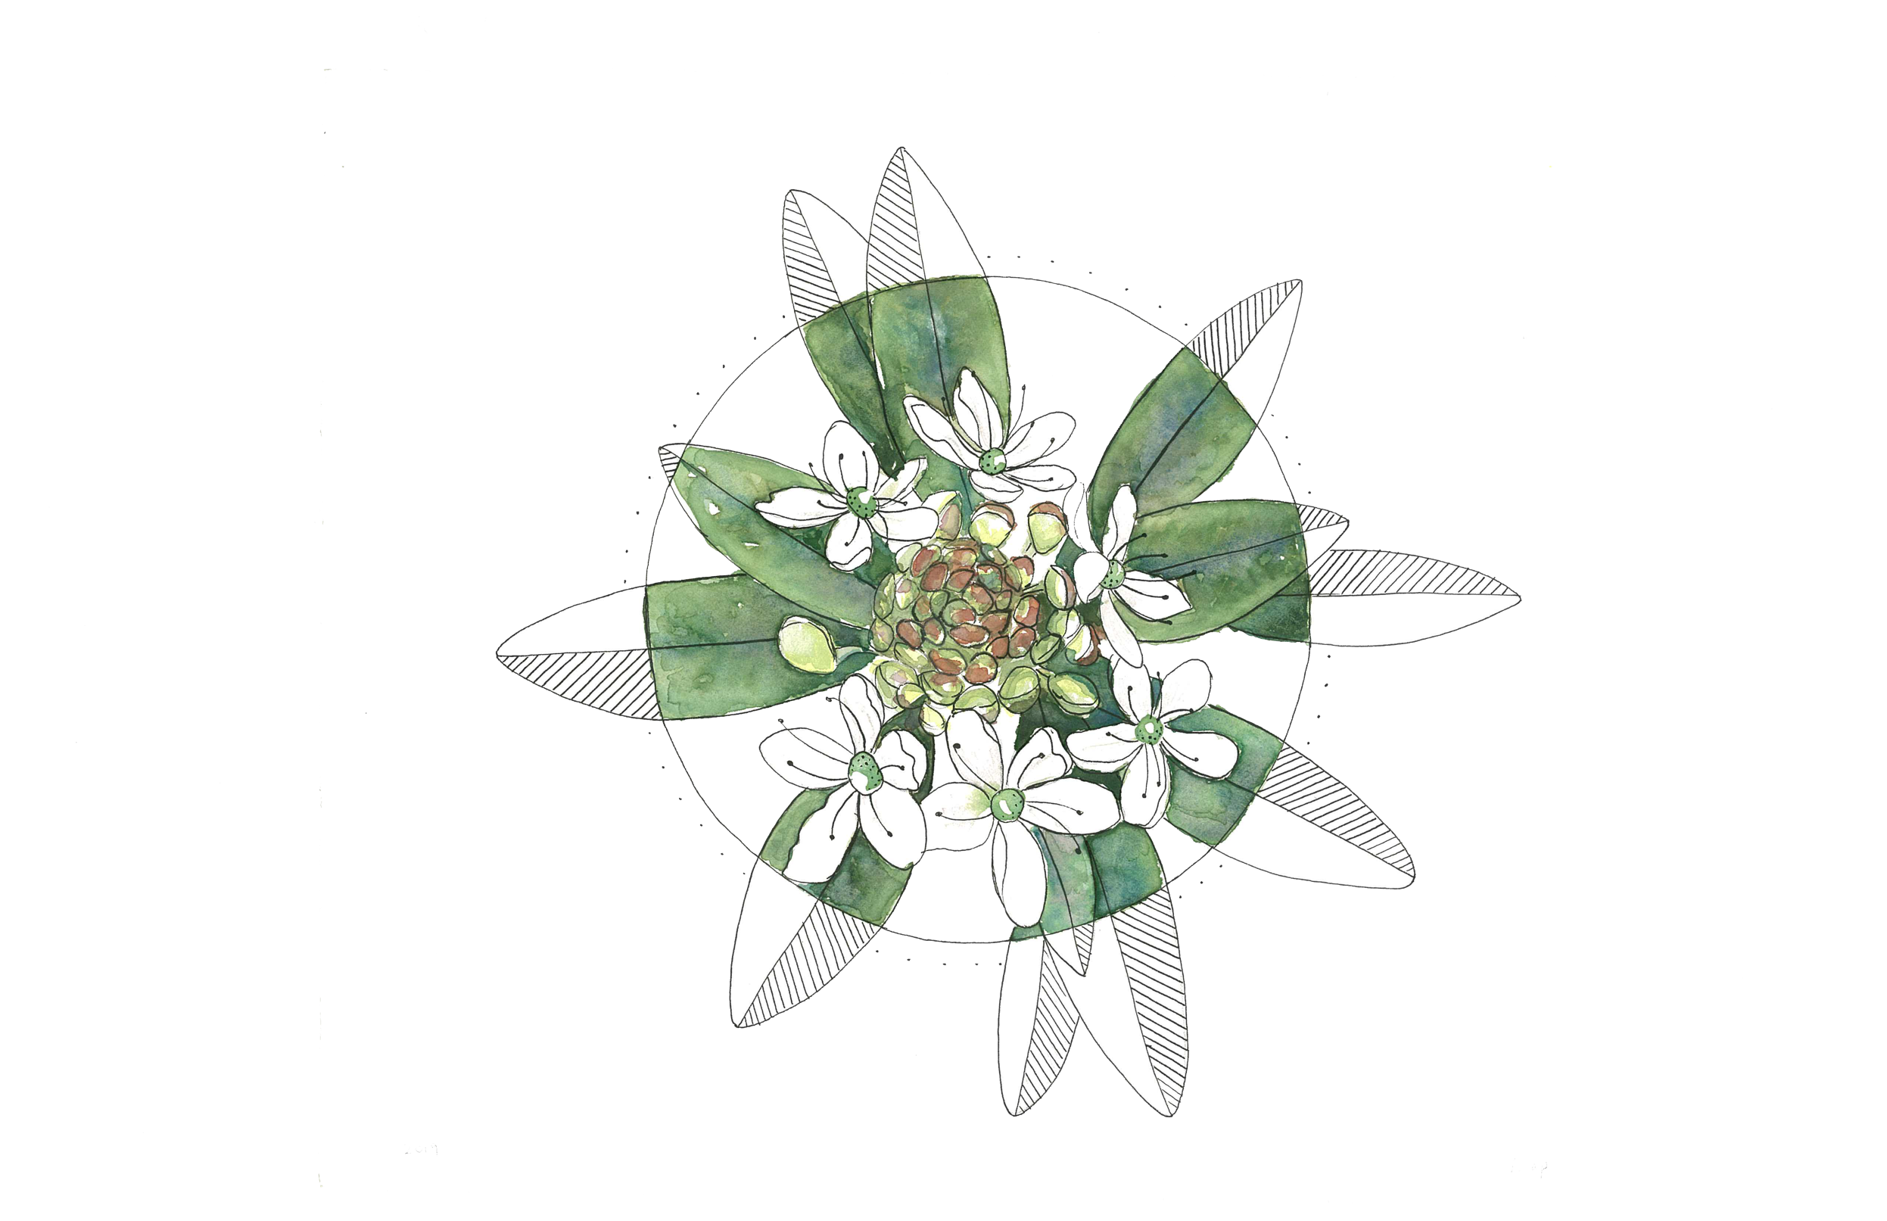
June 2022

Christopher Fletcher
Principal Investigator
Niap
Département de médecine sociale et préventive
Université Laval

Marie-Claude Lyonnais
Planning, Programming, and Research Officer
Centre de recherche, CHU de Québec

Nathalie Boucher
Research Methodologist
Organisme R.Es.P.I.R.E.

Mathilde Lapointe
Research Assistant
Université Laval

Ariane Benoit
Postdoctoral fellow
Université Laval

Linda Shipaluk
Community Coordinator
QS Project

Southern Quebec Inuit Association
Principal Knowledge User
and Community Partner Organization
qanuikkatsiqinirmiut.ca

This report is dedicated to the memory of Linda Shipaluk
our beloved friend and colleague who passed away in April 2020.

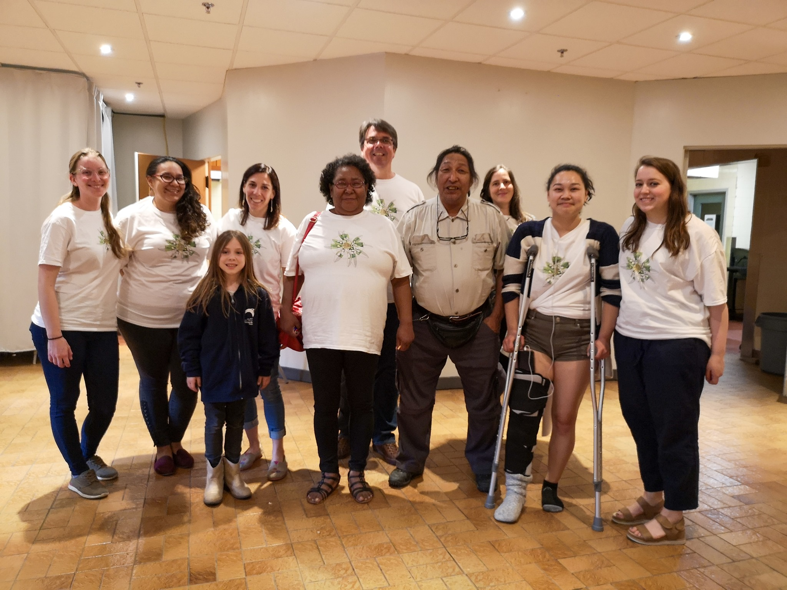
Photo of QS team members and supporters at the community launch of the project, Montreal, 1 June 2019.
From left to right: Mathilde Lapointe, Tina Pisuktie, Anya Pelletier, Marie-Claude Lyonnais, Annie Pisuktie, Christopher Fletcher, Laurentio Arnatsiaq, Nathalie Boucher, Linda Shipaluk, Madeleine Pawlowski.
Missing from the photo: Mylene Riva, Ariane Benoit.
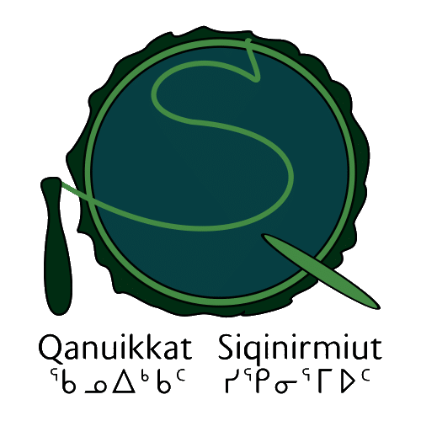

Executive summary
The Qanuikkat Siqinirmiut? (QS) project is a five-year, mixed-methods research study about the health of Siqinirmiut (Inuit living in the South) of Quebec. The project is a collaboration between the Southern Quebec Inuit Association (SQIA) and a research team based at Université Laval and McGill University. The SQIA is the designated knowledge user of the data and outcomes of the project. This report presents the results of the qualitative methods, including interviews and focus groups, conducted in the first phase of the project. The collected data have been organized and analyzed by themes. Most of the people we spoke with were in Montreal, but we also met with Inuit in other cities and towns in Quebec. The results provide an overview of the issues and contexts that influence the health and well-being of the Inuit population in southern Quebec. The information gathered to date is being used to develop a health questionnaire that will be implemented in the project’s next phase. While the COVID-19 pandemic has made planning the questionnaire phase challenging, we are hopeful that it will begin in the fall of 2022.
To begin the project, in 2019, we conducted a census of Siqinirmiut. We estimate there are around 2,200 Inuit living in southern Quebec.
The qualitative research phase has clearly demonstrated three main priority needs:
- Mental health resources with culturally knowledgeable and sensitive healthcare professionals for individuals and families.
- Access to culturally safe, informed, and easily accessible health services and programs.
- Opportunities to connect with other Siqinirmiut in a safe and welcoming space where Inuit languages, culture, and ways of being are promoted and valued.

Consequently, based on our findings to date, our recommendations are:
- The establishment of an Inuit community health clinic staffed by community members, nurse practitioners, and family medicine doctors.
- Identify and/or develop community mental wellness resources and train workers in this regard as soon as possible.
- The creation of a public health working group to begin to build strategies for managing infectious disease at the population level, establish networks of mental health support, and create pathways for addictions support.
- The creation of Inuit health and city navigator positions with a tailored training program. The navigators should be positioned within a community organization and make the link between Siqinirmiut and the healthcare system.
- The creation of a community drop-in centre with Inuit-relevant materials, activities for children, and links to arts and cultural activities.
- The development of information and training for people working in the healthcare system about the specific contexts of Siqinirmiut. These should be presented in a cultural competency framework that fosters cultural safety. The content should focus on the unique situation of Siqinirmiut as distinct from other Inuit and from other Indigenous peoples in the South.

Table of contents
List of figures iii
Introduction 1
Context 1
Research partnership 2
Project activities 2
Census of Siqinirmiut 3
Impacts of COVID-19 4
Research framework and definitions 5
Process and methodology 6
Sociodemographic profile of participants 7
Results 9
1. Physical and mental health 9
1.1 Physical health 10
1.2 Mental health 11
Summary: Physical and mental health 13
2. Access to health services 14
2.1 Culturally safe care 14
2.2 Communication skills 15
2.3 Knowledge of the Non-Insured Health Benefits (NIHB) program 15
2.4 Support for accessing health services 16
Summary: Access to health services 18
3. Community and belonging in the South 20
3.1 Social networks 20
3.2 Community cohesion 21
3.3 Drug and alcohol consumption 22
3.4 Desire to gather 22
3.5 Places and senses of community 23
3.6 Feeling welcomed and understood in the South 23
3.7 Experiences of being judged, observed, and targeted 24
Summary: Community and belonging in the South 26
4. Relations with the North and the South 27
4.1 Appreciation of the South 27
4.2 Relationship to the North 30
4.3 Accessing country foods 31
4.4 Travelling and visiting in the North 32
Summary: Relations with the North and South 33
5. Identity, culture, and language 35
5.1 Being Inuit in the South 35
5.2 Relations with other Indigenous people 36
5.3 Cultural activities 37
5.4 Multiple languages 37
Summary: Identity, culture, and language 40
Conclusions and recommendations for action 41
Conclusions 41
Recommendations for action 42
References 44

List of figures
Figure 1 Age distribution of participants 8
Figure 2 Place of origin 8
Figure 3 Housing situation 9
Figure 4 Languages spoken 9
Figure 5 Length of time in the South 9

Introduction
The Qanuikkat Siqinirmiut? (QS) project is a five-year, mixed-methods research study about the health of the Inuit population living in southern Quebec. The project is a partnership between the research team based mainly at Université Laval and McGill University and the Southern Quebec Inuit Association (SQIA). This report presents the results of the qualitative methods, including interviews and focus groups, conducted in the first phase of the project. The collected data have been organized and analyzed by themes, which are presented in detail in this report. Most of the people we spoke with were in Montreal, but we also met with Inuit in other cities and towns in Quebec. The results provide an overview of the issues and contexts that influence the health and well-being of the Inuit population in southern Quebec. The information gathered in this phase of the project is being used to develop a health questionnaire that will be implemented in the project’s next phase.

Context
It is well understood that Inuit experience significant health disparities compared to non-Inuit in Canada. Inuit suffer more from a range of chronic and communicable diseases, problems linked to the impacts of historical changes on their lives and lands, and inadequate access to resources and conditions that support individual and community health. While several studies have described the health of people in Inuit Nunangat in recent years, none have looked at the health status of Inuit in southern Quebec (Siqinirmiut hereafter). There is every reason to believe that health disparities experienced by Siqinirmiut are also significant. While we would expect that many of the health conditions afflicting Inuit in the North are also present in the South, the considerably different material and social conditions in the South likely influence health in distinct ways. Thus, the objective of the QS project is to better understand the particular conditions and status of health of Siqinirmiut.
The lack of health data about Siqinirmiut makes it difficult to know what the health needs of the population are, and thus to identify and develop services that respond to their needs. Because Siqinirmiut are not a large population, they tend to be invisible to the healthcare system. This is one reason why there are very few services and programs designed for the Inuit community in southern Quebec.
Additionally, because of jurisdictional issues the healthcare services provided to Inuit under land claim agreements and through northern regional health services are generally not available to Inuit living permanently in the South. This project aims to bridge this gap by providing Inuit-specific data to support development of services, programs, and policies for southern Inuit in Quebec.

Research partnership
After working with the director and board of the newly formed SQIA in 2017 and 2018, the QS team submitted a proposal to the Canadian Institutes of Health Research (CIHR) for a QS health survey. The proposal was funded in 2018 and additional funding has since been received from ArcticNet and Inuit Tapiriit Kanatami (ITK). Research funding proposals to back the project included letters of support from Inuit organizations Makivik Corporation, Saturviit, Ivirtivik, and ITK. The SQIA is the project’s designated principal knowledge user. The SQIA is a legally constituted non-profit organization that serves the interests of Inuit in southern Quebec. It is recognized and supported by the Makivik Corporation, the provincial Secrétariat aux Affaires autochtones, and Tungasuvvingat Inuit, a national urban Inuit organization. Together, the SQIA and research team decide on how the data will be used. The partnership is described in a Memorandum of Understanding and operationalized through a set of research principles (see Appendix 1) that orient the project relationship.

Project activities
In 2018 and 2019, a number of activities were undertaken to begin the project:
- Community Advisory Committee recruited and project meeting held;
- Statement of principles developed and adopted by SQIA board;
- Governance and research agreement, including OCAP™ (ownership, control, access, and possession) framework drafted;
- Census of Siqinirmiut conducted (+/- 2,200 Inuit in southern Quebec);
- Ethics approval gained from the Comité d’éthique de la recherche de l’Université Laval (CÉRUL approbation no. 2018-258);
- Logo, visual identity, and community tools (Facebook page, website) designed. Well-known Montreal artist Niap was commissioned to create the artwork;
- The IQI Inuit model of health described and validated for Siqinirmiut;
- Presentations given at national and international conferences;
- Interviews held on Nipivut, a bi-weekly Inuit cultural radio program;
- A booklet created on services for Inuit in southern Quebec;
- A tuberculosis screening intervention held in downtown Montreal (managed by Centre intégré universitaire de santé et de services sociaux du Centre-Sud-de-l'Île-de-Montréal and Département de santé publique de Montréal);
- Mapping performed of community resources and assets in Montreal (ongoing);
- Methodology and communication workshops conducted;
- Project launch community meeting held in downtown Montreal (1 June 2019).

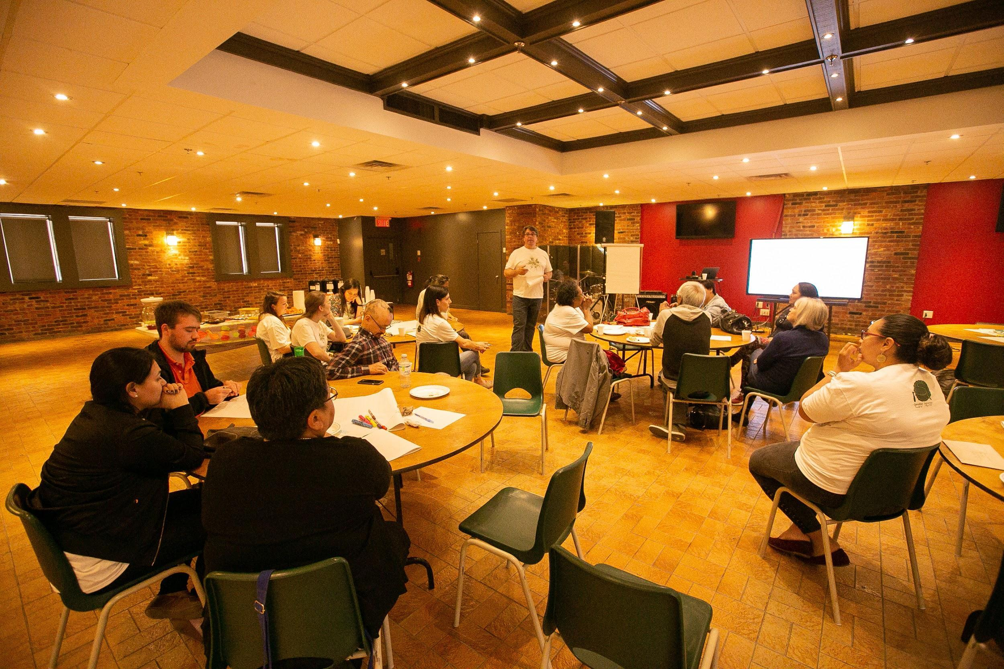 | 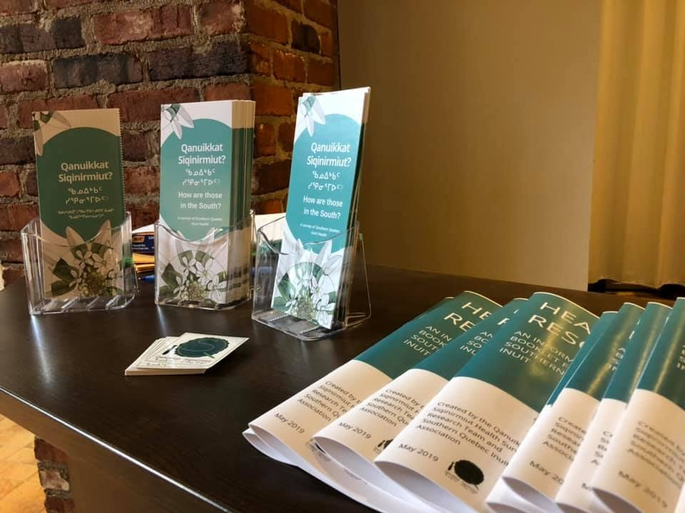
Project launch community meeting (1 June 2019) | Booklet on Inuit services in southern Quebec offered at the community meeting (1 June 2019)

Census of Siqinirmiut
As a first step in the QS project, we undertook a census of Inuit in southern Quebec in 2017. We estimate the population of Inuit in Southern Quebec to be around to 2,200 people, roughly 90% of whom live in and around Montreal. To determine the population of Siqinirmiut, we gathered beneficiary lists for Nunavik, Nunavut, and Nunatsiavut, as well as other documents that identified people living out of region. A master list was compiled, which was used to consult with SQIA staff, Inuit organizations, and others in the community to identify people who were no longer living in the South, who were deceased, or who were no longer in Quebec. Through the input of people with strong knowledge of the population, we also identified children who had not been entered on Inuit beneficiary lists. People in prison or detention, students in the South exclusively for education, and people in hospital and staying at Ullivik or other patient residences were not included in the count. Census work is complicated by a broad number of factors. Population lists are rapidly out of date because people are highly mobile, moving back and forth from the North, and few are aware that they can update their information with land claim organizations. There are different lists and ways of collecting information for each of the different regions of Inuit Nunangat. There are also Inuit in the South who have never lived in the North and have never had beneficiary status. Finally, there are people of mixed cultural ancestry who may not be known to the core of the Inuit community in the South but who self-identify as Inuk. Identifying all Inuit is a complex task and the figures we have arrived at are approximate. Nevertheless, we feel they better reflect the reality of the situation in southern Quebec than other published estimates. For example, 2016 Statistics Canada data reported only 675 Inuit in Montreal, a figure almost the same as in 2011. The results of our census work suggest two to three times as many Inuit live in and around Montreal.
Beginning in 2019, a variety of qualitative methods, including interviews, focus groups, and photovoice activities, were used to explore the experiences and perceptions of the health and well-being of Inuit in the South. While the qualitative phase has been paused because of the COVID-19 pandemic, we plan to continue with additional qualitative techniques when again possible. This information will feed into the development of a survey questionnaire that will reflect the realities of Siqinirmiut. The questionnaire will be reviewed, tested, evaluated, and administered during the second phase of the project, planned for 2022–2023. During the third phase of the project (2023–2024), data will be analyzed and compiled into a descriptive report. A final report will be shared with urban partners and relevant organizations after validation during the fourth phase (2024). This final report will include findings and recommendations for action.

Impacts of COVID-19
The COVID-19 pandemic has had a wide-ranging impact on Siqinirmiut. Interviews in this project were halted when public health measures were announced in March 2020, and we have not had the chance to do a detailed assessment of the disease on the population. We do know through media accounts and public health contacts that Inuit in the South have been afflicted by the disease and some have died of COVID-19. Infections among the homeless population generally were significant and a serious concern for the public health direction of Montreal. Several hotels in downtown Montreal were converted to shelters for the population in the winter of 2021 and warming tents were set up in key areas frequented by Inuit in the downtown core. While necessary and reasonable, COVID-19 countermeasures undermined other health determinants for many people, thereby magnifying the impact on and risk to the marginalized and vulnerable. The Makivik Corporation worked with city resources to send people to the North when it became clear that the pandemic would last a long time. We understand that close to 70 Inuit, many living in difficult circumstances, were helped to return to their home communities. Inuit in Nunavik were prioritized when the vaccines first arrived in Quebec but not Siqinirmiut, a situation that led to confusion and potentially exacerbated disease transmission between the North and South. Ultimately, Inuit were offered vaccination at the Native Friendship Centre in downtown Montreal and at a special clinic set up at the Douglas Hospital in Verdun in late April 2021. Inuit reported being unaware of the latter service and unclear as to when and where it was being offered. Regardless, many had already been vaccinated in Ottawa at the Akausivik Inuit Family Health Team (hereafter Akausivik), which began offering vaccinations in mid-February 2021 and reached out directly to individuals and organizations with their service offer.
The ongoing pandemic has made clear that there is no public health capacity for monitoring the Inuit population’s health in southern Quebec. Likewise, the absence of any Inuit-specific health services made outreach, testing, and vaccination programs difficult and incomplete. Consequently, we strongly recommend that Inuit-specific health services, however modest, be established as soon as possible.

Research framework and definitions
The conceptual framework for the Qanuikkat Siqinirmiut project draws from a Social Determinants of Health (SDoH) approach and is situated in an Inuit model of health. The SDoH is a well-established approach for identifying the root causes of health status and the disparity experienced by Indigenous people. We started by reviewing literature on Inuit-specific health determinants for guidance, including reports by ITK and the Nunavik Parnasimautik. Several members of the QS research team were also involved in the Qanuilirpitaa 2017 Nunavik Health Survey Community Component. During the Qanuilirpitaa project, we developed a culturally relevant model of health, known as the "IQI model,” and a set of eight SDoH factors relevant to community health in Nunavik: community, family, identity, food, land, knowledge, economy, and services. During the first year of the QS project, we explored the relevance of the IQI model with Siqinirmiut and are confident that the conceptual basis of the model is meaningful to people in the South and relevant to the research objectives of this project. The IQI model consists of three dimensions:
- Ilusirsusiarniq is roughly equivalent to “bodily health” in English. It suggests a condition of normal and unremarkable capacity; of being without pain, infirmity, or sickness; and able to carry out the tasks required of everyday life. The concept also carries the sense that health and the growth and ageing of the body follow a natural and intended shape of a normal progression across the lifespan.
- Qanuinngisiarniq is a broadly defined sense of well-being that encompasses feelings of being unworried, without pain, comfortable, free of emotional distress, and happy. It is related to peace of mind, calmness, fulfilment, and being able to move forward and carry on with ease.
- Inuuqatigiitsianiq is a form of social health that emphasizes the quality of interpersonal relations with people sharing the same place. Good relationships with family members, friends, neighbours, and people in the community are essential to health and well-being.
Each of these dimensions overlap with the others to describe health in a way that reflects the complexity of health and well-being for Inuit. Working with the IQI model acknowledges Inuit ways of knowing, thinking, and experiencing health, and provides a structure for describing health that reflects Inuit community realities. Methodologically, the IQI model provides an analytical structure for organizing the results of the qualitative phase of the research.

Process and methodology
This phase of the project used interview and focus group data to describe the contexts and conditions of health for Siqinirmiut. In June 2019, after obtaining ethics approval from the Université Laval, we began the first phase of the project, the qualitative data collection. The project was promoted through our networks and those of our partners, on Nipivut radio, and to community organizations involved with Inuit in Montreal, Quebec City, Sherbrooke, and Val d'Or. We used purposeful and snowball sampling methods to recruit participants and reach out to a wide range of Siqinirmiut. As the project became known among Inuit, some people contacted us directly to be interviewed. The response to the project promotion and community feedback has been very positive and constructive. As more than one person said when they heard that a study on Siqinirmiut health and well-being was underway, “It’s about time!” We take the encouraging, enthusiastic response as evidence that people are interested in the project and see value in taking part in interviews and other research processes.
Interviews were conducted in accordance with the ethical standards established by the project and approved by the Research Ethics Committee at Université Laval (CÉRUL approbation no. 2018-258). Participants were informed of their rights and our duties at the beginning of each interview, and no information was collected without participants' approval. Each interview was conducted by two members of the research team in the language of the participant's choice (French or English, with the possibility of Inuktitut). The meetings were held at a time and place of the participants’ choosing.
Between June 2019 and March 2020, the team conducted:
- 30 individual interviews (25 in Montreal, 2 in Quebec City, 2 in Val d’Or, 1 in Sherbrooke);
- 2 photovoice workshops in Montreal;
- 2 focus groups (1 in Val d’Or, 1 in Montreal); and
- 3 walk-along interviews (1 in Val d’Or, 2 in Montreal).
The methods resulted in over 45 hours of recorded interviews. The recordings were transcribed verbatim and an inductive thematic analysis of the contents undertaken. Analysis of the transcripts produced an initial thematic structure that was reviewed and discussed in full team meetings; themes were subsequently adjusted and interpretations clarified through several iterations of analysis and review. The IQI model and determinants served as an organizing framework throughout. The interviews have been supplemented with participant observation at key events by research team members, the contributions of the Community Advisory Committee members, by people attending project meetings, and by conversations with Inuit over the course of the project to date.

Sociodemographic profile of participants
During the study’s first year, we met with a total of 47 people. Thirty participants (64%) self-identified as women and 17 (36%) as men. No other gender identities were declared. We sought to speak with a wide range of Siqinirmiut and were successful in meeting a diversity of participants. In this qualitative exploratory phase of the project, our objective was to gather a wide range of perceptions and experiences. It should be noted that it is not known whether the background of the participants is representative of the Siqinirmiut population at large. A statistically representative sample will be sought in the next phase of the project when a survey questionnaire will be undertaken.
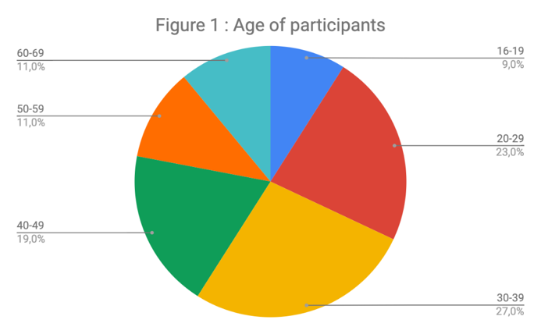

Age distribution of participants (Figure 1)
Most people were between 30 to 39 years of age. The eldest participants were 60 years old (3 women, 1 man) and the youngest was 16 years old (a woman).

Place of origin (Figure 2)
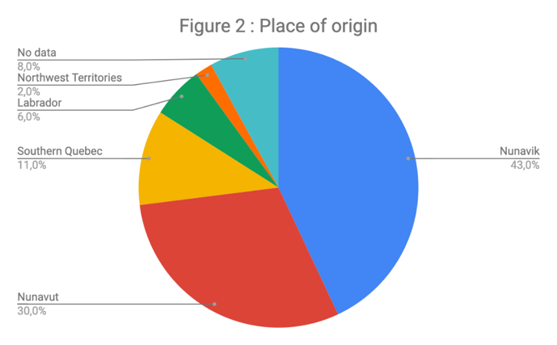
Out of 47 participants, 20 people were originally from Nunavik, 14 from Nunavut, and the others from different parts of Canada.

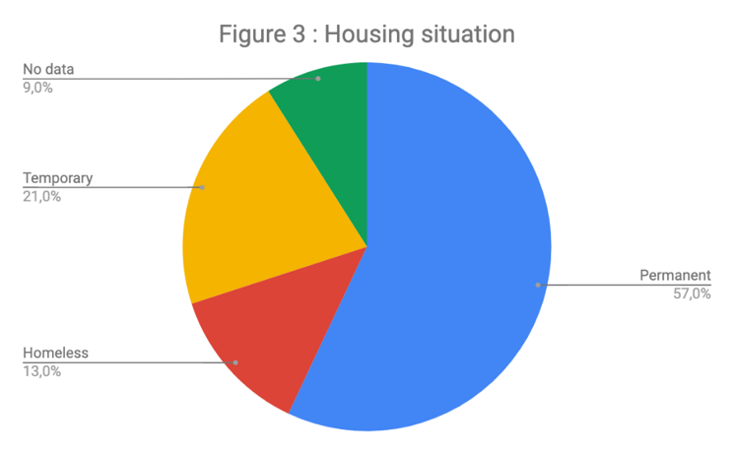
Housing situation (Figure 3)
Most people interviewed (57% percent) had permanent housing at the time of the interview, 21% reported a temporary or transitional housing arrangement, and 13% were experiencing homelessness.

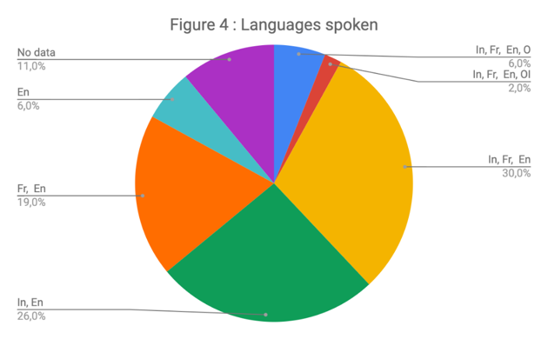
Languages spoken (Figure 4)
The linguistic dynamics of the interviewees is complex. A large majority of participants (85%) report speaking two or more languages. Inuktitut is spoken by 64% of participants, while 25% of the participants do not speak an Inuktut dialect.
Legend
In – Inuktitut; Fr – French; En – English;
OI – Other Indigenous; O – Other

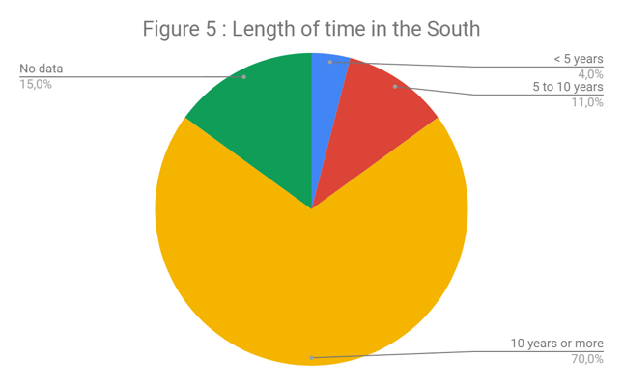

Length of time in the South (Figure 5)
Of those we spoke with, 70% had been in the South for 10 years or more. Fewer than 5% had been in the South for under 5 years, a finding that suggests the population is not typically transient.

Results
The following findings were derived from the thematic analysis of qualitative data gathered over the course of the project to date. The results are organized by broad themes that reflect the objectives of this phase of the research and the subjects raised by participants. The emphasis here is on describing the contexts that support and influence the health of Siqinirmiut as seen through the perspective of the IQI model.

Physical and mental health
During the qualitative phase of the research, people were encouraged to talk about their experiences of health in whatever way they found relevant. While we make the distinction between mental and physical health in this report, the two are not discrete entities for most people. In interviews, participants described how physical and mental health are intimately related. Many Inuit said that psychological disorders are expressed through physical ailments and, inversely, physical issues are also manifested through psychological distress. One participant explained,
I very much would like to take better care of my mental health. I know it's quite different because for me, the way that my mental depression, I don't know. … It comes out physically, so it'll show in me physically. (woman, 22, in Montreal for 5–10 years)
For mental and physical health, participants emphasized the importance of resilience and self-care, including having a healthy lifestyle, adequate living conditions, and being able to ensure their financial, food, and physical security. Both physical and mental health are made worse by socioeconomic precarity and uncertain living conditions, and they can be undermined by negative stereotypes and representation of Inuit.

1.1 Physical health
Participants reported a significant disparity between the physical health status of the homeless and vulnerable people and those who are part of the working population (including community workers) and students. Most physical health problems identified among people in precarious situations were related to high and persistent alcohol and/or drug use. Some people stressed that they had to reach critical physical and/or mental limits before taking charge of their health. People reported kidney infections, serious heart problems, and episodes of unconsciousness due to heavy drug and alcohol use. People who frequent the day shelters around Parc Avenue and Sherbrooke Street in Montreal often have visible injuries indicative of violence and accidents. Two Inuit women died in traffic accidents in August 2020 in this area. Their deaths might have been related to the fencing off of a vacant lot frequented by homeless people, an indication of how very small parcels of urban geographies are important to people with no place to live.
Additionally, some participants reported respiratory problems or suffered from permanent physical impairments due to serious accidents. One participant remarked, “Even though I have bad lungs, I smoke crack. Now I drink more, straight from the bottle sometimes, even hard liquor, to … maybe I'm hiding my pain, some of my pain, with the drugs and alcohol” (man, 42, in Montreal for more than 20 years). Others similarly explained their addictions by citing a need to cope with deep emotional distress, particularly managing grief or anger over the loss of loved ones, sexual abuse, and physical and psychological violence.
Finally, there is a relatively high prevalence of tuberculosis (TB) among urban Inuit, something also seen in northern communities. The return of this disease is troubling and suggests deeply entrenched conditions that undermine health and make Inuit particularly vulnerable. The frequent coming and going of Inuit from northern communities and the South shows how a holistic and transregional approach to chronic disease like TB is necessary. In February 2020, members of the research team and SQIA took part in a mobile TB testing event at Cabot Square organized by the Direction régionale de santé publique de Montréal. While the TB screening and surveillance work was curtailed by the COVID-19 pandemic, several cases where identified. Difficulties in following the treatment regime for TB, which can last many months, and high mobility of the population are confounding factors that suggest a broad scale approach to treatment and surveillance that links North and South should be developed.
In contrast with people suffering from addictions and homelessness, the portion of the population that includes workers, students, and community workers described themselves as fairly healthy. Some have reported suffering from minor illnesses (e.g., frequent sore throats and ears, anemia, urinary tract infections, various cramps, back pain, appendicitis, sprained ankles), which are not associated with an "unhealthy" lifestyle. A few special medical cases were mentioned, such as kidney disease or artificial limbs, which were explained by genetic factors or accidents. Many reported smoking cigarettes but did not report any significant negative health impacts. Most of the participants stressed the importance of having a healthy lifestyle through nutritious eating (cooking one's own meals, eating fruits, vegetables, and a good amount of meat, especially country food), being active (engaging in sports or physical activities daily, such as walking, cycling, or working out), and staying well hydrated to be physically healthy. A fuller and representative description of the health issued faced by Siqinirmiut will be collected in the second phase of the project.

1.2 Mental health
Mental health is a key issue for all Inuit living in southern Quebec. Almost all the people we met had a history of mental health issues and/or were currently struggling with mental health concerns. The mental health issues most frequently mentioned were depression, anxiety, self-harm/suicidal thoughts, and anger. These psychological issues were related to a wide set of factors linked to personal and collective traumas or various stressors in daily life. The participants overwhelmingly emphasized the importance of having access to more mental health resources—which need to be more easily and quickly accessible—with knowledgeable and sensitive healthcare professionals. They also widely reported using alcohol and/or drugs as a way to relieve pain at various points in their lives.
People we spoke with described different ways to constructively ease their minds and heal from difficult mental health concerns, including spending time alone, relying on friends or family members, reconnecting with cultural knowledge and pride, maintaining a healthy lifestyle (e.g., eating well and being active), spiritual practices, and confiding in others who share similar experiences (such as community workers or fellow Inuit), and psychotherapy. One participant reported, “I have a massive support group of people who believe in me and are proud of me and, you know, it’s not hard for me to find some [support]” (woman, 22, in Montreal for 5–10 years). Another person explained,
I have a lot of support. … I listen to my elders, which is what my great-great-grandfather taught me. He made sure I respected the elders, or how you’re going through your emotions. … You can turn to them. You can always talk, or be open to talk to them, which is, I always contact them whenever I’m going through that, emotionally. So that’s why I stand up more, and prayers help, I think, every here and there. (man, 42, in Montreal for more than 20 years)
The supportive role of friends and community members is fundamental to Siqinirmiut coping strategies and points to the great potential for people to help each other. While community support is part of the ongoing solution to collective and individual trauma, it should not be the only recourse people have. Inuit-focused medical, psychiatric, and psychological resources are lacking and needed. The impact of traumatic experience—including witnessing and experiencing violence, sexual abuse of children and adults, having family members and loved ones commit suicide, and disempowerment resulting from the colonial experience—on the mental health of Siqinirmiut is extremely serious.

Summary: Physical and mental health
The physical and mental health profiles of the Siqinirmiut population are significantly different than that of other southern Quebecers. The history of northern colonial processes and their impact on determinants of health today are the roots of health disparities experienced by Siqinirmiut.
- There are significant disparities in physical health between the different groups of Siqinirmiut. The homeless and vulnerable population have generally greater health challenges than the others.
- Little is known about the health of people beyond those experiencing the most intensive forms of homelessness and addiction.
- The ongoing high rates of tuberculosis among Inuit in the North is seen in Montreal as well. Inuit and refugees to Canada are the two populations with the highest rates of this disease.
- Most participants considered mental health a major concern for the southern Inuit population. Lifetime experiences of emotional trauma, abuse, and relational distress are very common.
- Personal and collective history significantly impact Inuit mental and physical health. Many participants reported having to cope with different types of traumas. The support of friends/family, workers from community organizations, or healthcare practitioners to find positive ways of dealing with trauma was greatly appreciated.
- Most participants reported having or aspiring to a healthy lifestyle. Avoiding using drugs and alcohol was a major issue in fostering health.

Access to health services
During interviews, we asked people about the issues they encountered around accessing services. It is often difficult for people to know what health services are available and how to access them. The pathways and barriers to services for Siqinirmiut are complex and have informational, social, physical, and cultural dimensions.
Many of the people who participated in this phase of the study use their Medicare card to access the healthcare system. There is general agreement that the system is complex and overloaded, creating sometimes long delays for appointments and wait times. Several people cited these conditions as a main reason why they avoid the healthcare system until absolutely necessary. Some institutional rules, such as denying access to people who are intoxicated and behaving in an aggressive/inappropriate way, were also problematic for some people. Some participants had sought medical attention in Ottawa at Akausivik, which offers Inuit-specific services. Others would wait until their next visit to the North, where they find it easier to access basic services in their home communities. The fact that in both instances the services offered are culturally adapted is a strong indicator of the need for such services in southern Quebec. It was also noted that low fluency in French and English was a significant barrier to accessing healthcare.
Finally, it is not uncommon for people to lose their Medicare card, which meant going through the administrative process to request a new one. Getting a new card can be frustrating and difficult, particularly for those already living precariously.

2.1 Culturally safe care
Participants appreciate health professionals who take a comprehensive, flexible, and sensitive approach with them, especially (but not exclusively) those who have some cultural and historical knowledge of Inuit. People stressed that understanding the impact of colonization and other traumas on contemporary health issues was important if healthcare professionals were to understand their specific needs. This was particularly the case for mental health issues. Being treated by caring and culturally sensitive practitioners improved the quality of the experience for most people we spoke with. Culturally knowledgeable and sensitive practitioners play an important role in reducing the risk of exposing people to prejudice or discrimination, while also improving the communication between patients and service providers. One participant reflected on her experience with a healthcare provider:
My nurse practitioner, she doesn’t know anything about the North, she just knows me. Um, she has another patient that’s Inuk that she’s mentioned to me. She really likes the other Inuk patient, so I thought that was nice. But she doesn’t know anything about Inuit culture. Yeah, she seems motivated to learn about Inuit. Whenever I talk about Inuit things, she’s listening to me. It’s really nice to see her listening so intently. (woman, 23, in Montreal for more than 10 years)

2.2 Communication skills
Most participants identified language as a key issue for being aware of the resources available, accessing resources, and interacting with healthcare professionals. Most Inuit we met prefer receiving health services from English-speaking providers because they are, in general, more familiar with English and could thus express themselves more readily. Respondents frequently noted a great need to have interpreters who can translate medical interaction in Inuktitut:
I think that’s a big issue—not knowing the language well enough, especially when you’re down South, it doesn’t help with what you would need to get for yourself, because you don’t always are able to explain what’s needed. I found that there’s a lot of Inuit that have lived down South for years who still don’t speak English well or French well, you know, to be able to express what’s in it. (woman, 41, in Montreal for more than 15 years)
Even for people comfortable in English and French, there are considerable barriers to finding services, making appointments, and getting to them at the right time. Some Siqinirmiut look to the services that Inuit living in Nunavik receive through Ullivik and question why they cannot have the same support in Montreal. The idea of an urban Inuit health navigator service was raised by several people over the course of the research.

2.3 Knowledge of the Non-Insured Health Benefits (NIHB) program
As a constitutionally recognized Indigenous people in Canada, Inuit have access to the Non-Insured Health Benefits (NIHB) program of Indigenous Services Canada. The health benefits of the NIHB include
- prescription drugs and over-the-counter medications;
- dental and vision care;
- medical supplies and equipment;
- mental health counselling; and
- transportation to access health services not available locally.
Access to the NIHB program, services varies widely across the Siqinirmiut community. For some, NIHB services are administered through their northern home community and regional health organizations. However, land claim benefits vary according to several different factors, including how long a recipient has lived in the South, whether they work for an Inuit organization, and which region of Inuit Nunangat they are originally from. Some in the community do not have access to services linked to beneficiary status because they have lived outside of Nunavik for more than 10 years and have lost status, or because of they never had beneficiary status for a variety of reasons. Accessing the NIHB was a common subject of conversation in interviews. The administrative procedures required to use the NIHB, including how to get a client number (“N number”) and gain access to services covered by the program, are challenging. Some people do not know about the benefits to which they are entitled and do not know when and where to ask for them. Many are uncertain how to obtain their N number. Several people we spoke with said that many services did not know about or accept their N number—this was especially the case for pharmacists, optometrists, and dentists. Variability in access to NIHB is a significant barrier to service, requiring people to pay out of pocket and then go through the complex process of applying for reimbursement. In many cases, people reported not having the ability to pay or being overwhelmed by the complexity of the reimbursement process. This led some to simply abandon their efforts to get the needed services. Nonetheless, some mentioned that having access to the NIHB program enables them to afford much-needed but otherwise inaccessible health services and goods (especially medications). For example, one person remarked,
Nunavimmiut who fall off the Nunavik system after 10 years, they fall and come under federal non-insured health benefits after 10 years, but they have to know that they are making this transition. This is for people who become permanent residents. They have to know that they made this transition, they have to know how to make that transition, they have to know who to contact to make that transition because there’s a bit of paperwork to do. It’s not transparent, it’s not easy. (man, 60, in Montreal for 5–10 years)
This person’s assertion, however, is not entirely accurate, but shows how the process of obtaining an N number can be quite complicated. As soon as someone moves South, they must apply for an N number to have access to NIHB benefits. The only difference is that, after 10 years outside of the region, they lose some of these benefits. There are many intricacies to the program because of different administrative processes from region to region. Nunavimmiut who work for Inuit organizations in the South maintain their beneficiary status regardless of how long they live out of region. Overall, the availability and accessibility of health benefits is variable and unequal for Siqinirmiut.

2.4 Support for accessing health services
Most participants were able to rely on different types of support, whether from their personal network (family and friends) or community-based organizations (especially community workers from day centres in Montreal) and fellow Inuit, to help them navigate healthcare services. Most often, people relied on their personal knowledge and connections to find “Inuit-friendly” resources (when they are aware of their existence) for mental wellness support, administrative assistance, interpreters, and transportation. In addition, several people described other ways they meet their health needs, including using over-the-counter natural remedies, repurposing leftover medication, consulting anonymously through the Médecins du Monde mobile clinic, and integrating different therapy groups (e.g., SQIA’s wellness groups and NA/AA meetings).
What I do say to clients always upfront is, I’m here, I’m a friend and I’m an ear, and if you need any help moving forward, you know, that’s what I’m here for. And I’m happy to coordinate all of that. And even when it comes to, like, translations making phone calls to specific places, I won’t actually make the phone call, but I will sit with the person while they’re trying to access whatever service that they need. I do a lot of coaching too, on building self-esteem, on building skills, or trying to help build skills or whatever. (woman, 36, in Montreal for 1–5 years)

Summary: Access to health services
While the Inuit population of southern Quebec is large and multigenerational, very few services have been developed or adapted to their specific health needs. Likewise, the ways that people access the healthcare system, their knowledge of how it works, and the sense of security (or lack thereof) that Inuit feel when interacting with health professionals is complex and can undermine the ability to identify and access relevant services in a timely fashion. It is clear the unique needs of Siqinirmiut are not recognized by the healthcare system and are consequently unmet. This is particularly true for mental healthcare and services. Additionally, many people do not know which services are available and so do not seek them out.
Health services offered by organizations such as Médecins du Monde are appreciated but targeted to people who otherwise have no medical services, those living in the downtown area of Montreal, and experiencing occasional or long-term homelessness and street involvement. Most of the Inuit population in southern Quebec is not in this situation, yet may still face significant challenges accessing health services. Despite the difficulties people face in accessing healthcare, there is much evidence of self-reliance and strength inherent in the Siqinirmiut community. The values of sharing and mutual aid support people in times of difficulty and are fundamental to the lives of Inuit in the South. Inuit organizations such as the SQIA and Makivik Corporation, and community organizations, including Chez Doris, Open Door, Val d’Or Native Friendship Centre, Projets Autochtones du Québec, make great efforts to help people, and their efforts are well received. There is near universal agreement that health services targeted to the entirety of the Siqinirmiut population are needed. The growing capacity and sophistication of the Inuit organizations in the South, coupled with the dawning realization that Indigenous-specific services are needed—and indeed a right that people hold in Quebec—makes this an opportune time to develop healthcare resources for Siqinirmiut.
- People working in the healthcare system have little knowledge of Siqinirmiut. When healthcare personnel do know of Inuit, their knowledge tends to be focused on the communities of Nunavik, and thus they make inaccurate assumptions about their patients and clients. Moreover, there are few information resources available.
- Inuit appreciate and access services designed for and by Inuit. Many people received COVID-19 vaccinations at Akausivik Inuit health center in Ottawa. The COVID-19 pandemic shows the dire need for a systematic public health program and services for Inuit. At present, there are none.
- Navigating the healthcare landscape is a complex process for most people we spoke with, and language and cultural differences pose significant barriers to effective healthcare and undermine their capacity to access health services.
- People were appreciative of service providers who were culturally aware or simply open-minded and respectful. While accessing the healthcare system is difficult, many people nonetheless reported positive individual experiences with service providers of all sorts.
- Most of the participants said they face many difficulties with health-related administrative procedures, especially for the NIHB program.
- The complexity of the health system and long waiting times to access services discourages some Inuit from seeking health services. Some chose to wait, occasionally for very long periods, and return to the North to see a doctor or nurse. Others only went to emergency rooms as a last resort.
- The participants stressed the importance of having a support network (community or personal) to help them navigate the health services and to find “Inuit-friendly’’ resources.

Community and belonging in the South
Research has shown that physical and mental health are often positively influenced by a person’s network of friends and relations available and the quality of those relations. Very similar observations were made concerning the Inuuqatigiitsianiq dimension of the IQI model of health, with its emphasis on collaboration and effective, harmonious relations. In this section, we first present our analysis of how social interactions influence all dimensions of health for Siqinirmiut. The results point to an important role for friends and relations in health and well-being. Second, we explore in detail the idea of community, its qualities and role in shaping health for Siqinirmiut. In Inuit Nunangat, a community is usually synonymous with the geographic location where people live, but even in the North there can be different notions of community at play. In the South, the idea of community is often quite complicated. Do all Siqinirmiut constitute a community simply by living in the South? Are people living in Montreal a different community than those in Quebec City? Do Siqinirmiut originally from Nunavut form a different community than those from Nunavik or from those raised in the South? The idea of community is intrinsically linked to belonging, sharing, and collaboration, all of which are important conditions for health. Given the relative newness of the Siqinirmiut population, we felt it important to explore what the idea of community means to people and how that may influence health.

3.1 Social networks
Siqinirmiut have diverse social networks that support them on many levels. For some, it is family members who are key in their lives; for others, it is friends and intimate partners. People spoke of how those in their networks provided guidance in accessing public services, material and financial help, or emotional support, all of which contributed to well-being. A participant talked about the occasions he visits his sister in a central Montreal neighbourhood: “When I’m deep down, you know. When you need to talk about important things” (man, 32, in Montreal for more than 10 years). For people who moved from Inuit Nunangat to the South, the feeling of being disconnected and lost in the city is common. Relationships among Siqinirmiut are very important for helping people adjust. One person described visits with friends and family when he felt lonely:
Well, I go see friends and family [in the South]. When I do, they usually have country food and we talk about things that happen in the North and it’s fun to immerse myself in that kind of environment. Because if I get homesick, I get a little piece of home. It’s some of the things that I do or I find a way to go back north. (man, 25, in Montreal for more than 10 years)
Homesickness—anarrasiktuq in Inuktitut—is a common experience for many Siqinirmiut. At times it is strong enough to cause a person to leave the South and return home. In some cases, jobs, apartments, and ongoing relationships are left behind. There is a pattern of cycling between the North and South—when people feel homesick, they return to the North, only to be reminded of why they left in the first place, which initiates a return south.
Siqinirmiut also have close friendships with non-Inuit, and many couples are of mixed Inuit and non-Inuit heritage. It is not uncommon for a couple who met in the North to eventually move South at the initiative of the non-Inuit partner. He or she often has the resources and knowledge to establish a home for the couple and, in many cases, their children. People report supportive relationship with other Inuit and non-Inuit friends. Younger bilingual or non-Inuktitut speakers report having ethnically and linguistically diverse groups of friends.

3.2 Community cohesion
According to several participants, a single, tight-knit southern Quebec Inuit community does not exist, but rather multiple communities of Inuit with loose and situational affiliations. For some, there is an emerging sense of a unified Inuit community, but for others it is "disconnected," "fragmented," and "fractured.” Participants gave various reasons for their impressions, including that southern Inuit come from all over the Inuit Nunangat and speak different dialects of the language. Others said they felt discriminated against or excluded from a group because of their weaker linguistic skills or different cultural practices. As one participant explained, “I don’t think Montreal is great for it [a sense of belonging], considering the number of Inuit that are here. I don’t know, it feels very disconnected” (man, 34, in Montreal for more than 15 years).
In Montreal, people we spoke with described four sub-communities of Siqinirmiut: (1) the homeless/vulnerable population; (2) the working population; (3) the transient student population; and (4) community and outreach workers. Furthermore, Siqinirmiut are scattered over a large territory, which makes it impossible to know almost everyone, unlike as in many northern communities. In addition, in Montreal, where the large majority of Siqinirmiut live, there is no single Inuit community centre or gathering place such as Tungasuvvingat Inuit in Ottawa. Until the SQIA was founded in 2017, there had been no representative Inuit association in the South for many years, and the services available to the Siqinirmiut were very limited. Participants suggest that the lack of community infrastructure and centralized Inuit-specific services prevent Siqinirmiut from gathering. The feasts and services offered by SQIA since 2018 are helping to foster a sense of cohesion among southern Inuit. As one participant remarked,
My sense here is that [a sense of community] is developing. … If people are living here permanently, that means that Inuit in Montreal need to have a voice and need to have places and activities and a sense of their own kind of community, I think. (man, 60, in Montreal for more than 10 years)
Moreover, the lack of Inuit role models or positive cultural representation in the South appears to complicate the possibility of a homogeneous community, particularly for generations of Inuit born in the city.

3.3 Drug and alcohol consumption
Substance abuse, particularly excessive alcohol consumption, is an important health problem that impacts physical health, well-being, and social relations for many Inuit. An individual’s substance use has a direct impact on belonging within the Inuit population. Some people find themselves excluded by others if they have a substance use problem and, in some cases, withdraw from “sober” friends because of feelings of shame or preoccupation with accessing drugs and/or alcohol. Participants explained that people who do not drink or use drugs may be harshly judge those who do. Furthermore, some are embarrassed and ashamed to be associated with the street-involved Inuit who frequent the Cabot Square or Parc Avenue and Sherbrooke Street areas in Montreal or downtown Val d’Or. They do not want to be judged or discriminated against by hanging out in those places, even if they have/had substance abuse issues themselves. One participant explained,
When I was working as secretary, cops would say that Native people are around this area during the day and being drunk. So, I always avoided that place. And every time I would drive by that place, there were always people over there with the paper bag or just the can. … Some places are ... I avoid places, so that I won’t be stereotyped or judged. (woman, 53, living outside the Montreal area for more than 20 years)
There is a thus a division within Siqinirmiut along the lines of those with alcohol or drug consumption problems and those who do not or who have worked through them.

3.4 Desire to gather
While there is a fractured sense of community identity, many of those who spoke with us expressed a strong desire to find ways to foster a broader sense of belonging and a more cohesive community. There was a strong desire to organize events that bring Inuit together—a desire that reflects a broadly held Inuit value of inclusive social events. The SQIA-sponsored community feasts in Montreal are popular events and attract people from outside the city. Community initiatives, such as the Christmas feast and the craft fair, are also very successful. Many people participate in the feasts for the pleasure of being surrounded by fellow Inuit and eating country food.
However, not everyone was aware of these events and some were hesitant to participate. The location of feasts was important and people mentioned that they prefer activities that are held in neighbourhoods easily accessible to them or with certain groups of people. One person employed by an Inuit organization in Montreal said they no longer went to the feasts because their work position made them a target for people who needed money or who had complaints to air. Others said they did not know how to find out about community activities. Finally, most of these cultural activities take place in Montreal, leaving those living elsewhere in the province to travel or not take part. With the COVID-19 pandemic and subsequent restrictions on feasts and in-person activities, new online activities have been launched that suggest ways to reach out beyond the city.

3.5 Places and senses of community
Most participants frequent specific locations in the city and will only occasionally go to other areas. People who frequent Cabot Square will not necessarily go to Lachine, and many from Verdun will only occasionally go downtown. Some will also move from one place to another to find a specific group according to their needs, their desires at the time, or the situation they find themselves in. For example, some will go to the Old Port if they want to sculpt and earn money; some will avoid Place des Arts if they do not want to be around people who are intoxicated. As life conditions and interests change, people will also join, leave, or avoid particular places and groups. For some people we spoke with, being healthy includes making choices about the people and places they frequent.

3.6 Feeling welcomed and understood in the South
Mutual support, hospitality, and welcoming between Inuit and non-Inuit in private life and public services, including health services, are experiences shared by participants. A participant living in a smaller city in Quebec described feeling at home and welcomed in that city. Several participants shared examples of positive interactions with medical providers, students, and teachers. Thus, relationships between Inuit and others in the South are diverse, ranging from very positive to very negative.
Non-Inuit knowledge of Inuit culture and the North facilitates mutual understanding, positive relationships, and health. As one person said about her interactions with medical providers, “He [a non-Inuit doctor] was talking to me about the North and the people that he met and it made me more comfortable to talk to him” (woman, 23, in Montreal for more than 10 years). When non-Inuit demonstrate genuine interest in Inuit and their realities, it also facilitates interpersonal bonds, as one student noted:
There was a lot of Inuit content [in class] that we are covering or Indigenous content, and a lot of people would end up wanting to be with me because I knew all this stuff. So, I felt like I was in the right program. I didn’t have to talk to too many people. Like people would just come talk to me. I wouldn’t approach people. People would approach me instead. So, that kind of helps. (woman, 23, in Montreal from more than 10 years)
However, even if non-Inuit have no knowledge of Inuit culture, sharing common values, a sense of humour, and open-mindedness are sufficient for creating positive interactions.
While many of the people we spoke with mentioned having good relations with non-Inuit, there is a history of mistrust and sometimes apprehension toward non-Inuit. Some participants linked their negative experiences with authorities to a generalized distrust of Qallunaat (non-Inuit), especially when interacting with public services, youth protection, and health and social services. One person expressed her fear when she had to deal with the police: “I’m scared of authority. So, it was an experience. … I was really scared when they showed up” (woman, 23, in Montreal for more than 10 years). The fear of authorities can prevent people from seeking help and accessing available resources. The role of trusted community organizations, friends, and relatives for helping people navigate resources is critical in these instances. The death of Joyce Echaquan, an Atikamekw woman from Manawan, Quebec, who was subjected to denigrating and racist language by healthcare personnel in a hospital in Joliette, has heightened the fear and mistrust many have towards the healthcare system. For some, memories of past negative experiences in healthcare settings were reignited by the evidence of Ms. Echaquan’s treatment.

3.7 Experiences of being judged, observed, and targeted
At times, Siqinirmiut feel self-conscious about how they are observed and perceived by people in the South. Several participants reported having been followed by security in stores and treated poorly by service people, which they presumed was because of their identity. There is a feeling that people judge all Inuit based on negative media representations, with an emphasis on tragedy and the situation of a small but visible number of street-involved people. One participant described being uncomfortable and very self-conscious on Mont-Royal Avenue, in the Plateau neighbourhood of Montreal, while having a coffee in a café. He suddenly felt he was being observed, presumably, he felt, because he looks Inuk. Participants believe non-Inuit lack information and a full understanding of southern Inuit, which, they suggest, leads to ignorance about the culture and, in turn, causes hurtful misunderstandings. In healthcare settings, current and accurate information about Siqinirmiut is an important need. “Educating the doctors and nurses on the way Inuit are today and what they might expect” (woman, 23, in Montreal for more than 10 years) is one suggestion to improve Inuit and non-Inuit relationships in health services.
Experiences of discrimination occur regardless of people’s life situations, including their level of education and income, which therefore impact Inuit quality of life in the South. Several people described difficulties and discrimination they face, particularly around housing, because they are Inuit. One participant explained,
And I’ve heard, like, another co-worker, like, she got discriminated and so they’re like, oh no, you can’t sign the lease. And then she had to look elsewhere and it took her longer than usual to find a place. And when you’re a student with an Inuk last name and then they sign up for a lease, they have difficulties as well. (woman, 24, in Montreal for more than 10 years)
Several participants said that looking and acting like a Qallunaat or having a European-sounding name reduced experiences of discrimination and eased access to housing and public services. People who have lived in urban areas for a long time insist on the importance of having knowledge of “Qallunaat culture” to facilitate life in southern Quebec. Others likened the experience of moving south to immigrating to a different country where everything is strange and unknown. One suggestion was that Inuit should be given training when they arrive in the South so they will know how things work and how to act so as to be well received. Such training would focus on communication skills, financial management, and understanding what public services exist and how they work.
Some people reported wishing they were not noticed or seeking to be invisible within the mass of people in the city. In other cases, Inuit are targeted by people who seek to exploit the vulnerabilities of those arriving in the South, particularly women. The vulnerabilities are exacerbated, in some cases, by negative life experiences, problematic drug and alcohol use, social isolation, and physical and/or emotional pain.

Summary: Community and belonging in the South
There are challenges and opportunities to foster Inuuqatigiitsianiq in southern Quebec. The people who participated in this phase of the research brought many insights to the complex notions of community and belonging. While it is common to speak of the “Inuit community” in Montreal, for example, the idea of community proved elusive when we looked closely. The sense of belonging or exclusion that people feel has real impacts on how they find their way to the resources and actions that lead to health. People tend to move between groups and locales over time and as the conditions of their lives change.
While the results show a diverse population with multiple organizing principles, it should be noted that diversity does not mean dysfunction or discord. Many people noted that a sense of unity of Inuit as a people is ultimately more important than the distinctions that may matter in everyday instances. People seek out other Inuit and will go out of their way to greet others they see in the city. For many, there is a sense of joy that comes with recognizing and talking with fellow Inuit.
- Friends and family in the South, as well as those in the North, support each other in many ways that contribute to well-being.
- Inuit face discrimination in the South in accessing employment, housing, and public services. Discrimination affects relationships between Inuit and non-Inuit.
- Having knowledge about life in the south and Qallunaat ways of doing things is an important learning experience for many. A lack of familiarity with southern ways can lead to confusion and social isolation.
- Good relationships between Inuit and non-Inuit can be experienced when non-Inuit have some knowledge of Inuit culture or the North, or when they show an interest in knowing more about it. These experiences are also possible when Inuit and non-Inuit simply share common values.
- Distinctions amongst and between Siqinirmiut include coming from different regions of Inuit Nunangat, varied cultural knowledge and linguistic skills, length of time in the South, and scattered places of residence throughout the city and province. There is an important distinction between those with and without substance use problems.
- Activities, events, and community initiatives, such as the feasts organized by the SQIA, are appreciated but not known to everyone. People living in Quebec City and Val d’Or would like to attend events in Montreal but may not be able to travel.

Relations with the North and the South
Interviews, go-along, and photovoice methods included questions about the relationship between place and health with a focus on how northern and southern environments influence the people’s health. Interviewees talked about a variety of ways that the natural and built environment of the South impacted their physical, mental, and social health, and about their relationship with northern communities.
The places where people are born, grow up, live, work, move to, and move away from feature prominently in the discourses of Siqinirmiut. For many in the South who were raised in the North, there is both a longing for northern spaces and a sense of relief to be free of them. Others who were brought into the youth protection system at a young age and raised in fosterage and adoptive arrangements in the South have relatively few connections to northern communities. There are also those who move back and forth from the North to the South as living conditions and personal circumstances change. The housing shortage in the North, changing relationships with family members, relationship breakups, and a build-up of stress and hurt can all cause people to move south. With the high price of air travel, the chance to come south for training, meetings, hospital appointments, or as a patient escort are sometimes the catalyst for a move. Siqinirmiut who have been incarcerated at various points in their lives may stay in the South after release. Problems of returning home for ex-detainees are well known and there are efforts between the corrections system and Makivik Corporation to help people upon release. Finally, many Siqinirmiut have lived their entire lives in the South and so for them it has always been home. Far from being somehow “out of place” in the towns and cities of southern Quebec, Inuit have multiple place attachments and connections to the North and South. While the physical distance between the two is considerable, the conceptual and temporal distance between the North and South is shrinking.

4.1 Appreciation of the South
A few people who spoke with us said they feel urban, comfortable, and even “immensely at home here” (man, 60, in Montreal for more than 10 years) in a way that they did not in the North. For some, moving to southern Quebec was a deliberate choice by people seeking opportunity or other ways of living that were not available or possible in the North. For several people we spoke with, moving south was a choice brought on by experiences of violence, particularly sexual violence. Leaving the North was a way to move past these experiences and to protect their young children from the abuse they had suffered in their own upbringing. As one person succinctly put it, “I came here so the man who was abusing me wouldn’t abuse my children” (woman 40s, more than 20 years in the South). In these instances, moving south can be seen as a harm-reduction measure aimed at improving living conditions.
Participants noted particularly appealing characteristics of urban areas. These include: the cultural diversity of people; the wide range of businesses and activities; the openness to the world; and the many resources available in the South, including health services, housing, education, and work opportunities, as well as public transit and car-sharing options such as Communauto. Some said that the absence of family or community pressure was a positive aspect that allowed them to live independently. Even the constant background noise of the city was reassuring to some who described it as a relief compared to the silence of northern communities, which they found anxiety provoking.
Income and housing stability were cited as major contributors to the health of Siqinirmiut. According to participants, there is a greater chance of finding housing and employment in the South than in the North, and the range of housing options was well appreciated. Nonetheless, several participants noted that they had experienced discrimination when looking for housing and employment. Others said that they did not know how to find accommodations and work when they arrived. There are several resources in the South to support people in their search for housing and work. According to the participants, these resources should be better known and adapted to the reality of the Inuit and their specific needs. There is broad agreement that Inuit arriving in the South are unprepared for the distinct conditions of life there. Having identification, knowing how find an apartment, knowing what signing a lease implies, getting a driver’s licence, registering children in school, and knowing where to get specific health services were among the many challenges people brought up.
Many people we spoke with had favourite places they liked to go to experience natural beauty, reflect, or meet friends. Places of nature, especially those with a wide view of the water or a starry sky, bring an important sense of physical and psychological relief. As one woman explained,
Yeah, I go pick up people … and say, I'm going picking berries, I can take you, but you have to pay for yourself. So, I take some people, go pick blueberries, raspberries, strawberries, and, in fall, apples. Or I'm going to go driving around. I take them to the mountain, or by the sea, by the water because … all that counts is by the water. So, when they see water, they go, “Oh God, that feels good.” Because down here we see buildings, trees, and this and that, and back home we see water, and when they go by the water or the mountain, it seems to fix. … Because we grew up seeing far. (woman, 49, more than 10 years in Montreal)
Interviewees saw some of Montreal’s characteristics as a nuisance. For example, they cited the humidity, lack of space (notably for gardening), city noise, density, and artificial lights as qualities that undermined their health.
Some neighbourhoods were seen as too dense or dangerous, while other areas (e.g., downtown Val d’Or; the Atwater area in Montreal) were avoided because they generate discomfort, sadness, frustration, and irritation. This is particularly true of the Cabot Square/Atwater area in Montreal, an urban park and long-time hangout for people who misuse drugs and alcohol. Some interviewees described seeing family members and friends there on a regular basis, and other people said they were frightened or ashamed by the sometimes-rowdy behaviour of intoxicated people in the square.
A number of deaths of people who frequented the area also triggered sadness for interviewees. This area is undergoing a transformation as the Montreal Children’s Hospital that occupied the south side of the square is now gone and a high-rise condo building has emerged in its place. Additionally, for several years patients from the North in Montreal were housed at the YMCA just west of the square. In 2017 the arrangement with the YMCA ended and patients are now housed at Ullivik, a dedicated patient residence in Dorval, west of Montreal. Ullivik has emerged as an important social centre for Siqinirmiut who regularly visit with family and friends in town for health appointments. In some cases, people will go to Ullivik simply to be with Inuit and with the hopes of finding people they know staying there. Likewise, the nearby Les Jardins Dorval Shopping Centre is a regular spot to meet Inuit who live in the West Island or who are in town for healthcare or meetings.
Our analysis shows that the participants engage more with places they value in the South when they have the physical, mental, or social health to do so. Conversely, they observe (for themselves or others) some level of suffering from having no place to enjoy, or from not having the means to visit those places when they were suffering physical, mental, or social health difficulties. One woman remarked,
Fresh air. That’s one of the first things I always enjoy when I get up North, the change of air. I didn’t go camping much when I lived up North, but the few times that I did those were really fun. I can’t really do them in the South. So that’s something I miss about the North. (woman, 23, in Montreal for more than 10 years)
All of the people we spoke with have at least some first-hand experience and knowledge of the northern physical environment (e.g., the landscape, light, space, quiet) and links to Inuit identity and culture. As the previous quotations illustrate, it is sometimes through comparison with the North that people in the South determine what is important for their health (e.g., water, fresh air). Furthermore, some people mentioned that as their knowledge and familiarity with the South increased over time, their appreciation of the territory and its inhabitants increased.
Finally, positive markers linked to Inuit culture in the urban scape, such as art pieces, institutions, and activities like the community feasts organized by the SQIA, added to their sense of belonging and comfort.

4.2 Relationship to the North
Relationships with family and loved ones in the North are a significant factor in the health and well-being of many Siqinirmiut. There is a strong recognition that Inuit identity and cultural strength are drawn from a northern geography and history, and that these contribute to a sense of self and individual strength. The relationships people maintain with other people and places in the North can deeply influence health and well-being but may also be a reason to leave a home village or region. The emotional impact of being connected to people, and to being able to maintain those connections despite the distance, is very important. Social media has an important role in maintaining ties between the North and South. News of family and friends, trips on the land, and hunting and community events are widely shared and greatly appreciated. At times, social media can bring sadness and shock when, as was reported several times, people find out about deaths and tragedies at home through Facebook. This is a recurring theme that is related to culturally appropriate ways of announcing bad news and comforting people who are grieving. For most people, a healthy relationship with the place and the people the North is an important contributor to health and well-being.
Participants born and raised in northern communities, and who feel a strong cultural attachment, usually have denser networks of relations with the North than those who left during early childhood, were moved south or placed in youth protection at a young age, or were born in the South. People who grew up in a northern community also tend to have more connections with relatives and friends living in the North and maintain stronger bonds even if they are not able to visit often. Overall, the relationships that most participants maintain with Inuit in the North are highly valued and important. The positive emotional and family bonds are a critical source of social support, and people also report that they like to keep aware of what is going on in their hometown. Relationships are maintained through social media, phone, or in-person visits. Many people say the distance or their financial means have not significantly impacted their relationships with loved ones. For some, the distance was comforting because it allowed them to maintain a distance from the “drama” and complexity of day-to-day issues in their homes. Even people who are homeless or precariously housed maintain connections with people in the North with the help of community organizations such as the Native Friendship Centre of Montreal, Open Door, and other organizations. One participant explained,
Here in a Native Friendship Centre Montreal? Yes, we have access to calling them [family]. They give us free access to calling long distance. They got computers. So, it’s not that hard to keep in touch with home if you’re dedicated to keeping in touch. (man, 42, in Montreal for 5 years)
Not everyone wants to maintain contact with the North, however. Several people reported that they had left the North because of experiences of violence, abuse, or trauma in their homes and communities. For many of them, being in the South, and comparatively disconnected from their home community, is means to reduce their exposure to difficult and risky situations. A few participants mentioned that even a short visit to their hometown could trigger bad memories and symptoms of post-traumatic stress. They felt the need to limit their travel to the North and were vigilant about their living situation when they were there. Others said they did not plan to go back at all because they did not want to face certain people or situations. Much like they avoid certain areas in the South, cutting all links to the North was the only way for some to protect their physical and mental health. As one participant shared,
I would never be able to go back and live there. Impossible. … My parents wanted to take me away from all the nastiness. Because, and I’m saying that openly, if I had stay there, I would be a grandmother today. I would have never finished school. I would have done nothing with my life. I’ve hated my parents for uprooting me, but now, I thank them because I have done something. (woman, 40, living in the Montreal for more than 15 years)
Some people we spoke with had completely cut ties with their home communities and families as a way to protect themselves and manage extremely difficult life experiences.

4.3 Accessing country foods
Access to country food is a challenge for Siqinirmiut, many of who often crave northern foods. Having a network of family who send food south is a material example of supportive North–South relations that contribute to all three dimensions of the IQI model of health. Even with the help of people in the North, there are many obstacles to getting country food, including the vagaries of air travel, cargo handling, payments for shipping, and having the means to pick up packages at the cargo centre at the airport.
Having access to country food was also, as one participant put it, a way to “get a little piece of home” (man, 24, in Montreal for more than 10 years), one that is both physically and psychologically nourishing, and thus contributes significantly to Qanuinngisiarniq. Many participants explained that a good network of northern friends and family was crucial to get country food. One participant added that the absence of such a network can be painful: “I really, really love pitsik, so I was really sad that I didn’t have anyone to give me some pitsik” (woman, 23, in Montreal for more than 10 years).
In addition to individual sources of country foods, Inuit and community organizations also receive and distribute foods on occasion. The feasts at the SQIA are one highly appreciated venue; so, too, are the occasional meals provided at Chez Doris, Projets Autochtones du Québec, and the Native Friendship Centre. Some Inuit organizations get regular shipments of meat and make them available to employees. Makivik Corporation distributes shrimp to many Siqinirmiut from its fishery company every year at Christmas time, a gift to the community that is widely anticipated and very appreciated. Most of the country food provided through organizations is only available in and near Montreal. People living in other cities rely mainly on friends and family members for country food. Enhancing the availability of country foods is a long-standing goal for Siqinirmiut, and regularizing food availability would have important health repercussions for the community.

4.4 Travelling and visiting in the North
Many participants reported feeling divided in their connections and sense of belonging to the North and their life in the South. People talked about being homesick and torn between wanting to be in the North and staying in the South. While they believe the city offers has some advantages, they missed their family and friends, the sense of community of the North, the land, and the food. For some, this feeling translated into seeing themselves as being a bit "de passage" (man, 60, in Montreal for more than 10 years) even though they have been in the city for many years. They did not feel fully rooted in the South, were still struggling with a desire to go back, and had a weaker sense of belonging to the city. Some had more serious issues with the city, felt uncomfortable, and wished they could move back to their hometown or at least visit more often, but going back to the North was not possible. A few people talked about having broken relationships with their hometown for various reasons and felt they would not be welcomed. They doubted they would have a place to stay and would be ostracized by others in the community.
For other people, money was the most serious issue. Many could not afford the high cost of plane tickets and mentioned that they would only go back for funerals when family members or communities would contribute to the travel expenses. Other participants mentioned that they could not afford the cost of living in the North, which was seen to be too high for a proper living. Overcrowding and years-long waiting lists for housing made moving back north near impossible. As one man explained,
I would be hunting, would like to have a house, like a normal one, but in four to five years. Four on a waiting list. No, we hate the city. It’s hard, it’s humid, we’re Inuit, we’re from the land of ice and snow. We’re sweating. I’m sweating. We don’t like Montreal, but we got no choice. Funny, funny how are we, it’s a lesser evil of two evils. (man, 31, in Montreal for more than 5 years)
Like the participant quoted above, several people felt they had no choice but to stay in the South and it was affecting their well-being. Life in the South for some is a “good enough” situation where the basic needs of life are taken care of, but the sense of home and belonging is missing—a sentiment that one person summed up by saying, “I’m not an urban Inuk; I’m an Inuk in the city.”

Summary: Relations with the North and South
Siqinirmiut have complex and diverse relations and connections to the North and the South. For some, the South and the city truly are where they want to be and where they feel at home. For others, the city is an occasional or temporary living situation determined by circumstances and individual life experiences. People of mixed identity and ancestry may find it comforting and interesting to have multiple connections and networks of people to engage with. Other people question the legitimacy of their Inuit identity in the city and have a difficult time situating themselves within a community.
Life in the South has some advantages for achieving Ilusirsusiarniq. Housing is relatively plentiful, there is work for many, and advanced health services are close although difficult to access at times. Perhaps the greatest challenge to Ilusirsusiarniq is in the ready access to drugs and alcohol, which both undermine health and are often symptomatic of troubled experiences, trauma, and ongoing ruptures with people in home communities. Several accidental deaths over the course of the project to date in downtown Montreal are indicative of the degree of this problem. We also note that suicide, known to occur at very high rates in the North, is also present among Siqinirmiut.
Accessing country foods is an important challenge for people living in the South. When these foods are available, much sharing and community building takes place around them. Thus, Inuuqatigiitsianiq may be enhanced, or at least made evident in the act of gathering and sharing food. Generosity and taking pleasure in the company of other Inuit is not, however, dependent on food from the North and can occur in restaurants and people’s houses. Inuuqatigiitsianiq is not an exclusively Inuit phenomenon; many Siqinirmiut have profound friendships and rewarding relationships with non-Inuit in all their diversity. Being together in comforting and supportive environments is a critical part of living well for Siqinirmiut.
- A positive relationship with people and family in the North, as well as in the South, is often linked to health and well-being.
- Many women reported moving South to escape violence, abusive home situations, and to shield their children from negative life experiences.
- Physical distance from friends and family in the North does not necessarily impact healthy relationships and may in some cases improve them.
- Having good connections to people in the North facilitates accessing country food, which is often closely linked to experiences of health and well-being.
- Many people in the South have a complex relationship with their home communities. People living with trauma from past experiences can feel both an intense homesickness yet avoid going back because of the emotional weight of their experiences.
- Some people report being comfortable in neither the North nor the South and will move frequently between the two.
- Some participants are in the South by choice, others because they lack the means or opportunity to live in the North.

Identity, culture, and language
For people living outside of Inuit Nunangat, negotiating identity, culture, and language are significant and complex events in everyday life. Inuit are a small minority population even amongst Indigenous people in the South. The contexts of identity formation and opportunities for cultural knowledge and skills development, cultural expression, and language learning and use are, in many cases, limited for Siqinirmiut. This is especially the case when compared to northern communities where Inuit are the majority and the key features of identity, culture, and language are present in everyday life. Nevertheless, identity, culture, and language are vital sources of personal and collective affirmation, mutual recognition, and resilience for Siqinirmiut.
The sense of Inuuqatigiitsianiq or community togetherness is very much evident at the feasts held by the SQIA in Montreal since 2017, where many Inuit come together for food, games, conversation, and companionship. Many people report feeling a sense of relief at being with other Inuit in an environment where Inuit ways of being together, talking, and eating are normal and not subject to the stares of non-Inuit. For some, the circumstances that brought them to live in the South are difficult and can make them question their feelings of belonging and cultural pride. Many in the South reported feeling disconnected from their homeland, family, and culture, some never having had the chance to really know them at all. For them, identity, culture, and language can be sources of self-questioning, alienation, and provoke feelings of inadequacy. These feelings can change throughout a lifetime as circumstances of life shift and people find sources of strength within themselves, locate themselves within a community, and find opportunities to share with others.
Identity, culture, and language were common points of discussion in the interviews and other qualitative methods during the first phase of the project. They were often evoked as both contributing to and undermining the possibility of health for individuals and the Siqinirmiut population at large.

5.1 Being Inuit in the South
The lack of contemporary representation of Inuit people and history in urban areas was a source of frustration for some. In some public spaces, Inuit and First Nations’ life and history are referred to as events from the past, as one participant’s remarks illustrate: “I just did history in high school and it bothered me so much how the language was past tense …, but we’re still here! Inuit still go out on the land and hunt. You’re talking about it like we just … disappeared” (woman, 41, in Montreal for more than 10 years). Several spoke about how the broad and ever-present conditions of colonization have undermined their identity. People of mixed, multiracial, and multicultural backgrounds spoke of their unique processes of identity formation and struggles to situate themselves. For others who were raised in the South in non-Inuit families through fosterage arrangements, transcultural adoption, or because of family separation of culturally mixed parents, contact with Inuit culture was restricted or non-existent. Finally, for many second- and third-generation Siqinirmiut, the South is their home and few have spent much time in the North. They report that they sometimes struggle to be recognized by other Inuit and do not feel a particular attachment to the North.
While some said they have been raised to be more “white” than Inuit in the South, others expressed how they always felt themselves between southern and northern identities. There was, however, broad agreement among participants that it was important to know where they come from. A number of people reported that they were actively trying to learn more about the North and Inuit culture and were hoping to visit their community of origin. One participant noted,
One day my brother will take me [to my community], so I'm excited to go. … I'd love to advocate for all the kids who grew up like me and don't feel as close to any culture that they could be with. It's hard not knowing who you are. (woman, 19, born and raised in Montreal)
This picture, however, is nuanced. Several participants shared their pride in being Inuk, especially when they were knowledgeable of their history and benefit from strong family bonds. Others mentioned a change in their opinion about their identity once they gathered information about Inuit history through talking with their relatives or their own research. Learning to respect and be proud of Inuit history helped people to recover from trauma and enhanced health and well-being. The possibility to strengthen cultural identity in urban areas also exists when people eat country food, speak an Inuit language, practice traditional activities, and share common experiences in private or public spaces. As one participant put it,
If you are secure in your identity and you know who you are, you incarnate that culture, you contain that culture, you’re a walking example of that culture. It includes things like having my family’s values, my parents’ values in terms of how you treat people. You treat people with respect and kindness, and you are welcoming. (man, 60, in Montreal for more than 5 years)

5.2 Relations with other Indigenous people
Many participants said they had significant interactions with other Indigenous peoples and cultures in their daily lives. A number of people who spoke with us are of mixed Inuit and other First Nations heritage. Some spoke of moving comfortably between different Indigenous activities and communities. They acknowledged that they share common interests, activities, and resources with other Indigenous people in the South. As one participant stated about the taking part in activities with First Nations communities, “It makes me feel like I belong. It makes me feel that I'm home” (woman, 31, living outside the Montreal area for more than 15 years). Several participants attend First Nations-oriented venues on a regular basis, have a network of First Nations friends, and participate in activities like pow wows because they feel welcome, enjoy the activities, or feel a connection to the culture. As one person said, “it’s close enough” to Inuit cultural activities (man, 25, living in Montreal for more than 15 years). The Inuuqatigiitsianiq dimension of health is thus demonstrated in the feelings of welcomeness and pleasure that many feel amongst other Indigenous people in the South. Nevertheless, the need for cultural activities and services specific to the Inuit population was often expressed; many people wish they could attend more Inuit-oriented activities.

5.3 Cultural activities
In an urban setting, cultural identity is closely linked to the possibility of practicing traditional activities that ease the mind and bring joy and pride. Sewing, beading, throat singing, and carving are practiced for fun and personal fulfillment. They can be done alone, with friends or family, or in community situations. Several participants said that they learned these skills by themselves and/or by asking relatives to teach them. One woman explained,
I learned it my way, I taught myself because I have always. … My mother never taught me because she didn’t know how to sew. And so, since I was young, I’ve been asking, “Can you show me, can you show me?” And four or five years ago, I said, “Okay, nobody’s going to show me, let me learn how to sew.” (woman, 49, in Montreal for more than 10 years)
Art is an activity through which Inuit culture is shown in public spaces. Carvers are particularly popular in the Old Port of Montreal. Their skills allow them to generate income, practice an Inuit arts tradition, and, in working together in small groups, develop healthy relationships with friends. The 2019 SQIA Inuit Craft Fair, for instance, successfully attracted many Inuit and non-Inuit alike and put Inuit skills on display.
Opportunities to practice cultural activities were unequal among participants. Some people reported having relatively easy access to places where skills can be practiced and where there were opportunities to speak Inuktitut. This is especially true among those who have a good connection with family in the North and several friends and family members in the South. There is a strong interest among participants to have access to more cultural events in the South and more chances and places to experience and transmit cultural knowledge. As one participant remarked, “More access to our culture, for sure. You know, me, if I had someone, you know here, who knew about drum dancing, I would always be after that person, ‘Show me, show me’” (woman, 40, in Quebec City for more than 10 years). While positive about the value of cultural skills, this statement also speaks to unmet needs in the community.

5.4 Multiple languages
The language dynamic of southern Quebec plays an important part in the health of Siqinirmiut. Language abilities allow people to participate in community events, maintain interpersonal relationships, be secure in their cultural identity, seek appropriate health services, effectively communicate with healthcare providers, and navigate the places they live in. French is the official language of government and thus health services. English is widely spoken in Montreal but less so in other parts of the province. Inuktitut is spoken by a strong majority of Inuit in the South; 64% of the people we interviewed said they were Inuktitut speakers. Most Siqinirmiut come from Nunavik or have family connections there. There are, however, people from across Inuit Nunangat and several Inuktut dialects are spoken in southern Quebec. While these dialects are often largely mutually intelligible, there are differences that are sometimes also reflected in social distinctions. Many Siqinirmiut speak more than one language and almost all people we spoke with were comfortable in French and/or English, although we know this is not the case for everyone in the South. Inuktitut health and social services are almost non-existent for Siqinirmiut. By contrast, people who live in Nunavik who must travel to Montreal for healthcare services are supported through the Nunavik Regional Board of Health and Social Services, which includes Inuktitut translation, lodging in Montreal at Ullivik, and transportation to and from appointments.
Roughly one quarter of the people who participated in the qualitative phase of the research did not speak Inuktitut, a fact that was difficult for many. For those born and raised in urban areas, opportunities to learn and speak the language were very limited. For others living in the South, being away from home communities meant that their Inuktitut skills were eroding. As one participant put it, “Yeah, I do speak Inuktitut, but I’m losing it because I don’t spend a lot of time with Inuit. My boyfriend is not Inuit, he’s white so I don’t get to speak Inuktitut at home, but I’m trying to teach him” (woman, 23, in Montreal for more than 10 years).
Obstacles to speaking an Inuit language include the pressure to function in French and English as well as the lack of speakers, resources, and places to learn and practice. Some participants said they were able to regain their language skills because they are in contact with Inuit speakers. For those who did not learn the language as children, having friends to practice with is invaluable. Many expressed a desire to learn. The Inuit language remains important in the definition of cultural identity even for people who are not regular or fluent speakers.
One participant stressed that it was challenging to focus on learning or speaking Inuktitut because of the importance of French and English in everyday life in the South: “I’m trying to relearn my language, in a sense. But it’s still hard, because I’m so adapted to understand French and I’m still trying to adapt to English” (man, 28, in Quebec for more than 10 years). It is common for people to be timid to use their language when their skills are rusty or underdeveloped. They fear being mocked or belittled by fluent speakers because of less-than-perfect language skills.
Speaking French and English eases access to the healthcare system and other public services, employment, and education. But the level of second-language skills can vary. One participant noted that she has relatives who still do not speak English well even though they have lived in southern Quebec for many years:
Like, even for my mom, like, she’s been here for 38 years, she still doesn’t know how to express her needs in English as well as she can in Inuktitut. And then if there’s no one there to understand Inuktitut for what she needs, you know, how was she supposed to be able to get the proper aid that she wants? (woman, 41, in Montreal for more than 10 years)
People noted a need for interpreters and documentation in Inuktitut, but they also recognized that language in the South is complicated by the fact that people speak different dialects. It is difficult to have an interpreter for each dialect and to select one dialect for public documentation. English is the most common second language for Inuit, and participants expressed their desire to have access to more services in English to reduce miscommunication:
I think it’d be helpful to have English doctors and nurses because Inuit speak English. Well, most Inuit that I know speak English. … So having a majority English place instead of a majority French place. (woman, 23, in Montreal for more than 10 years)
Contrary to other southern Canadian Inuit populations like that of Ottawa, people in southern Quebec also need to have French skills. Not being fluent in French can pose several difficulties affecting health and well-being. Reluctance to access public services or misunderstandings during interactions are among the obstacles commonly mentioned. One participant explained how she is unable to speak with her doctor:
My family doctor is French, she only speaks French and I speak English. So, my nurse practitioner is in the middle of me and my doctor, because she speaks English and French, so she [speaks] to the doctor for me and translates everything for me. So, it’s kind of complicated there. (woman, 23, in Montreal for more than 10 years)
This is not an isolated case, as several participants have medical providers who do not speak English in southern Quebec.
Finally, fluency in French is important for employment and can limit the ability of Siqinirmiut to find and keep work. Inuit organizations are preferred places of employment, but the available jobs often require advanced education and training, which few people possess.

Summary: Identity, culture, and language
Identity, culture, and language are important parts of healthy living. A state of Ilusirsusiarniq is directly impacted by people’s ability to locate and access health services, to understand healthcare providers’ instructions, and to feel motivated to act on their health concerns. With respect to Qanuinngisiarniq, the ability to be understood, feel part of a cultural tradition, and be recognized as Inuk are profoundly important to a sense of emotional well-being. Some people spoke of a continual self-questioning of their identity because of their culturally diverse parentage and their particular upbringing. The perception that others hold of Inuit also impacts Qanuinngisiarniq. Experiences of stereotyping, being mistaken for an intoxicated person, or being looked down upon because one is Inuk makes it difficult for people to feel at ease and welcome in public spaces. Finally, identity, culture, and language are foundational to Inuuqatigiitsianiq. The relationships between Inuit, with others, and with the institutions they access are shaped by Inuit identity, language, and culture. There is much positive recognition and mutual support within the Inuit community in all its diversity. People who are only partially connected to their Inuit heritage are seeking more ways to become engaged and to learn.
      - Some Siqinirmiut reported a lack of knowledge of Inuit culture and history which undermined their self-esteem, emotional and psychological health. Most of the people reported that their sense of pride of being Inuit is strengthened by opportunities to learn and share with others.
      - Activities that focus on building community, helping people, and sharing are significant contributions to individual health and collective well-being.
      - Learning and practicing Inuit culture, history, and traditional activities—particularly arts—brings a sense of well-being and favours social cohesion. These activities also helped people to overcome trauma and enhanced health and well-being.
      - The possibility for participants to practice cultural activities depends on their social networks. Community organizations play an important role for people with small social networks.
      - There is a strong desire among many people to improve their Inuit language skills, but some feel shy or uneasy when speaking Inuktitut in public.
      - Having little or no knowledge of French can sometimes prohibit access to health and other services.
      - Many people recognize their backgrounds as consisting of Inuit and other heritages. Having more than one cultural identity is seen as a strength and resource to be valued, but some people of mixed heritage report their cultural legitimacy as Inuit questioned by other Inuit and Qallunaaq alike.

Conclusions and recommendations for action
The material gathered during the qualitative phase of the QS project is being used to inform the development of the questionnaire. Understanding of many of the issues and questions that have been identified in the qualitative analysis will be explored in detail and across the population of Siqinirmiut. Development of the questionnaire is well underway, and the team should be able to start interviewing in spring 2022. Our target is to interview between 275 and 350 respondents. The survey will provide a more detailed and complete understanding of the health of the population.

Conclusions
In the research activities undertaken as part of the first phase of the QS project, respondents spoke of their health and social needs as profound and not well met at the present. Three priority needs emerged in the analysis of the qualitative data gathered to date:
- Access to more mental health resources. Mental health resources need to be more easily and quickly accessible and be provided by culturally knowledgeable and sensitive healthcare professionals. Most respondents considered mental health a major concern for the southern Inuit population. The support of friends, family, and workers from community organizations was often noted and greatly appreciated. Yet, while personal and community support is part of the ongoing solution to collective and individual trauma, it should not be the only recourse people have. Inuit-focused medical, psychiatric, and psychological resources are lacking and needed. We cannot understate the impact traumatic experiences—including witnessing and experiencing violence, sexual abuse of children and adults, having family members and loved ones die from suicide, and the disempowerment resulting from the colonial experience—on the mental health of Siqinirmiut. Appropriate mental health resources are increasingly seen as a precursor to reducing the negative effects alcohol and drug consumption, often used as coping mechanisms to deal with negative or troubling emotions caused by trauma.

- Access to culturally safe and informed health services and programs. Existing health services and programs (especially the NIHB program) need to be geographically, linguistically, culturally, and administratively more accessible to Siqinirmiut. Increased support should be offered to help urban Inuit navigate the healthcare system, including transportation, Inuktitut-English-French translators, and Inuit patient navigators. To foster positive experiences with health services and programs, service providers should have access to cultural safety trainings and be better informed of services and programs southern Inuit are entitled to and may access. Moreover, culturally specific health services, such as the ones offered at Akausivik in Ottawa, are needed in southern Quebec. Such services would significantly reduce the cultural, linguistic, and administrative barriers that undermine access to health services and the quality of the care for Siqinirmiut. Furthermore, Inuit appreciate and access services designed for and by Inuit, and they reported aspiring to a healthy lifestyle. Siqinirmiut are inclined to seek services when they are recognized as culturally specific, efficient, and trusted. Finally, special attention should be dedicated to the homeless and vulnerable population, who have generally greater health challenges than the others, and to health issues that affect Inuit more than others including tuberculosis.

- Opportunities to connect with other Siqinirmiut in a safe, welcoming space where Inuit languages, cultural practices, and ways of being are promoted and valued in order to foster a sense of community and to create a stronger support network. There is a strong desire among many Siqinirmiut to share country foods, speak Inuktut, practice cultural activities, learn more about Inuit culture and history, or simply spend time together. Support for families and the vulnerable population such as food baskets, childcare services are needed. Activities that focus on building community, helping people, and sharing are significant contributions to individual health and collective well-being. Such activities foster a sense of belonging, connectedness to others, cultural legitimacy, pride, self-esteem, and emotional and psychological well-being. They foster a sense of being at home, comfortable, and well supported in southern Québec, and they ease the homesickness and emotional weight sometimes experienced by Siqinirmiut for their home communities.

Recommendations for action
The qualitative research phase has clearly demonstrated several immediate needs among Siqinirmiut. From our findings to date, we recommend:
1) The establishment of an Inuit community health clinic staffed by community members, nurse practitioners, and family medicine doctors.
2) Identify and/or develop community mental wellness resources and train workers in this regard as soon as possible.
3) The creation of a public health working group to begin building strategies for managing infectious disease at the population level, establishing networks of mental health support, and creating pathways for addictions support.
4) The creation of Inuit health and city navigator positions with a tailored training program. The navigators should be positioned within a community organization and serve as links between Siqinirmiut and the healthcare system.
5) The creation of a community drop-in centre with Inuit-relevant materials, activities for children, and links to arts and cultural activities.
6) The development of information and training for people working in the healthcare system about the specific contexts of Siqinirmiut. These should be presented in a cultural competency framework that fosters cultural safety. The content should focus on the unique situation of Siqinirmiut as distinct from other Inuit and from other Indigenous peoples in the South.

References

Canadian Institutes of Health Research (CIHR). (2016, June 8). Knowledge user engagement. https://cihr-irsc.gc.ca/e/49505.html
First Nations Information Governance Centre. (n.d.). First Nations Principles of OCAP™. https://www.afn.ca/uploads/files/nihbforum/info_and_privacy_doc-ocap.pdf
Fletcher, C., Riva, M., Lyonnais, M-C., Saunders, I., Baron, A., Lynch, M., Baron, M. (2021). Definition of an Inuit cultural model and social determinants of health for Nunavik. Community Component. Qanuilirpitaa? 2017 Nunavik Inuit Health Survey. Quebec: Nunavik Regional Board of Health and Social Services (NRBHSS) & Institut national de santé publique du Québec (INSPQ). https://nrbhss.ca/sites/default/files/health_surveys/The_IQI_Model_of_Health_and_Well-Being_report_en.pdf
Gracey, M., & King, M. (2009). Indigenous health part 1: Determinants and disease patterns. The Lancet, 374(9683), 65–75.
Greenwood, M., & de Leeuw, S. (2012). Social determinants of health and the future well-being of Aboriginal children in Canada. Paediatrics & Child Health, 17(7), 381–384.
Greenwood, M., de Leeuw, S., Lindsay, N. M., & Reading, C. (2015). Determinants of Indigenous peoples' health. Toronto: Canadian Scholars’ Press.
Institut national de santé publique du Quéec (INSPQ). (2008). Survey highlights. Nunavik Inuit health survey 2004, Qanuippitaa? How are we? Quebec: Nunavik Regional Board of Health and Social Services (NRBHSS) & Institut national de santé publique du Québec (INSPQ). https://www.inspq.qc.ca/pdf/publications/774_ESISurveyHighlights.pdf
Inuit Tapiriit Kanatami (ITK). (2008). Inuit statistical profile. https://www.itk.ca/wp-content/uploads/2016/07/InuitStatisticalProfile2008_0.pdf
Inuit Tapiriit Kanatami (ITK). (2014). Social determinants of Inuit health in Canada. https://www.itk.ca/wp-content/uploads/2016/07/ITK_Social_Determinants_Report.pdf
King, M., Smith, A., & Gracey, M. (2009). Indigenous health part 2: The underlying causes of the health gap. The Lancet, 374(9683), 76–85.
Makivik Corporation, Kativik Regional Government, Nunavik Regional Board of Health and Social Services, Kativik School Board, Nunavik Landholding Corporations Association, Avataq Cultural Institute, & Saputiit Youth Association. (2014). Parnasimautik consultation report. https://parnasimautik.com/2014-consultation-report/
Public Health Agency of Canada (PHAC). (2019). Public Health Agency of Canada (PHAC) 2018–19 Departmental results report: Supplementary information tables. https://www.canada.ca/en/public-health/corporate/transparency/corporate-management-reporting/departmental-performance-reports/2018-2019-supplementary-information-tables.html
Reading, C. L., & Wien, F. (2009). Health inequalities and the social determinants of Aboriginal peoples' health. Vancouver: National Collaborating Centre for Aboriginal Health.
Richmond, C. A. M., & Ross, N. A. (2009). The determinants of First Nation and Inuit health: A critical population health approach. Health and Place, 15, 403–411.
Smylie, J., & Firestone, M. (2017). Our health counts urban Aboriginal health database research project. Community report Inuit adults, City of Ottawa. http://tungasuvvingatinuit.ca/wp-content/uploads/2017/12/Our-Health-Counts-Urban-Indigenous-Health-Database-Project-Inuit-Adults-July-2017.pdf
Smylie, J., Firestone, M., Spiller, M. W., & Tungasuvvingat Inuit. (2018). Our health counts: Population-based measures of urban Inuit health determinants, health status, and health care access. Canadian Journal of Public Health, 109 (5-6), 662–670.
Statistics Canada. (2016). Aboriginal population profile, 2016 Census - Montréal, Territoire équivalent [Census division], Quebec. https://www12.statcan.gc.ca/census-recensement/2016/dp-pd/abpopprof/details/page.cfm?Lang=E&Geo1=CD&Code1=2466&Data=Count&SearchText=Montreal&SearchType=Begins&B1=All&GeoLevel=PR&GeoCode=2466&SEX_ID=1&AGE_ID=1&RESGEO_ID=1
Wallace, S. (2014). Inuit health: Selected findings from the 2012 Aboriginal Peoples survey. http://www.statcan.gc.ca/pub/89-653-x/89-653-x2014003-eng.pdf

For more information
Christopher Fletcher, Principal Investigator: christopher.fletcher@fmed.ulaval.ca
Mathilde Lapointe, Project Coordinator: mathilde.lapointe.1@ulaval.ca
Tina Pisuktie, SQIA Executive Director: sqiainfo@gmail.com

Visit us at:
Website: https://qanuikkatsiqinirmiut.ca/
Facebook: https://www.facebook.com/qanuikkatsiqinirmiut

•
ᒪᓕᑦᑕᐅᔪᑦᓭᑦ ᖃᓄᐃᒃᑲᑦ ᓯᕿᓂᕐᒥᐅᑦ ᑐᖕᖓᕕᖏᓐᓂᑦ

1. ᐱᕙᓪᓕᖁᑎᐅᓗᓂ ᓄᓇᓕᒻᒧᑦ
- ᐱᓇᓱᐊᕐᑕᖅ ᐊᑐᕐᓂᖃᕐᓗᓂ ᐱᕙᓪᓕᖁᑎᐅᓚᖓᔪᖅ ᐃᓄᑐᐃᓐᓇᓕᒫᓄᑦ ᓄᓇᓕᒻᒥᐅᓄᑦ.
- ᐱᓇᓱᐊᕐᑕᖅ ᑕᑯᑦᓴᐅᑎᑦᓯᓚᖓᔪᖅ ᓄᓇᓕᒻᒥ ᐃᓗᓯᓕᕆᓂᕐᒥ ᖃᓄᐃᖕᖏᓯᐊᕐᓂᒧᓪᓗ ᐱᓇᓱᐊᕐᑕᐅᓴᐅᑎᒋᒋᐊᓕᓐᓂᒃ.
- ᑯᐯᒻᒥ ᖃᓪᓗᓈᑦ ᓄᓇᖓᓂᒥᐅᑦ ᐃᓄᑐᐃᓐᓀᑦ ᖃᐅᔨᒪᑎᑕᐅᓂᐊᕐᑐᑦ ᐱᓇᓱᐊᕐᑕᒧᑦ ᑐᕌᒐᕐᓂᒃ, ᐱᓇᓱᑦᑕᐅᒍᓯᖏᓐᓂᒃ ᓄᐃᑕᖏᓐᓂᓗ.

2. ᐃᓚᐅᑎᑦᓯᓗᓂ ᐃᓄᐃᑦ ᓄᓇᕐᔪᐊᒥ ᑕᑯᓐᓇᕈᓯᖓᓂᒃ
- ᐃᓄᐃᑦ ᖃᐅᔨᒪᐅᓯᖏᑦ ᐃᓕᑕᕆᔭᐅᓯᒪᓗᑎᒃ ᓲᓱᒋᔭᐅᑦᓯᐊᓗᑎᓗ
- ᖃᐅᔨᓴᕐᑌᑦ ᐱᓇᓱᑦᑕᐅᓂᖏᑦ ᐊᑐᕐᓂᐊᑐᑦ ᐃᓄᐃᑦ ᖃᐅᔨᒪᐅᓯᖏᑦᑕ ᐊᑐᕐᑕᐅᒍᓯᖏᓐᓂᒃ ᐱᓇᓱᑦᑕᐅᒍᓯᖏᓐᓂᓗ
- ᐱᓇᓱᐊᕐᑕᖅ ᑐᖕᖓᕕᓕᒃ ᐃᓚᐅᔪᓕᒫᑦ ᑐᑭᓯᒪᑦᓯᐊᑎᑕᐅᓂᖏᓐᓂᒃ ᑐᑭᑖᑦᓯᐊᕈᓐᓇᓂᐊᕐᒪᑕ ᖃᐅᔨᓴᕈᑎᓂᒃ ᖃᓄᓪᓗᐊᑎᒋᓗ ᐃᓚᐅᕕᖃᕐᓂᐊᒪᖔᕐᒥ.

3. ᓲᓱᒋᔭᖃᑦᓯᐊᓗᓂ ᐃᓄᑐᐃᓐᓇᓂᒃ ᓄᓇᓕᓐᓂᓗ
- ᖃᐅᔨᓴᕐᑐᖃᕐᓂᓕᒫᖓᓂ ᓇᐅᑐᐃᓐᓇᓄᑦ ᖃᐅᔨᒪᔭᐅᑎᑦᓯᒋᐊᖃᖕᖏᓂᖏᓐᓄᑦ ᐱᔪᓐᓇᐅᑎᖓ ᐊᑐᑦᓯᐊᑕᐅᖏᓐᓇᓂᐊᕐᑐᖅ.
- ᐱᓇᓱᐊᕐᑕᖅ ᐃᓱᒪᒋᔭᖃᕐᓯᒪᔪᖅ ᓇᔪᕐᑕᖏᓐᓂᒃ, ᐃᓅᖃᑎᒌᓐᓂᖏᓐᓂᒃ ᑮᓇᐅᔭᓕᐅᕋᓱᐊᕐᓂᑯᓪᓗ ᖃᓄᐃᑦᑐᓴᔭᐅᒻᒪᖔᑕ ᖃᐅᔨᓴᕐᓂᒧᑦ ᐃᓚᐅᔪᑦ, ᐊᒻᒪᓗ ᖃᐅᔨᓴᕐᓂᐅᑉ ᓱᕐᕃᓂᕆᒍᓐᓇᑕᖓᓂᒃ ᓄᓇᓕᒻᒥᒃ.
- ᖃᐅᔨᓴᕐᓂᒧᑦ ᐃᓚᐅᔪᑦ ᐱᓇᓱᖃᑎᒌᑦᑐᓄᓪᓗ ᐃᓚᐅᔪᑦ ᓲᓱᒋᔭᐅᑦᓯᐊᕆᐊᖃᕐᓂᖏᑦ ᐊᑐᕐᑕᐅᓯᐊᕐᓗᑎᒃ ᐃᓱᒪᖃᕇᕐᕕᐅᒍᓐᓀᓗᑎᓗ.

4. ᐃᑉᐱᒋᔭᖃᑦᓯᐊᓗᓂ ᐱᑕᖃᕆᐊᖓ ᐊᑦᔨᒌᖕᖏᑐᓂᒃ ᖃᐅᔨᒪᐅᓯᕐᓂᒃ ᐱᓂᐊᕐᓂᖃᕈᓯᕐᓂᓗ
- ᓄᐃᑦᓯᖃᑎᒌᓐᓂᖅ ᖃᐅᔨᒪᔭᐅᓚᖓᔪᓂᒃ ᓄᑖᓃᒃ ᐱᓇᓱᐊᕐᑕᐅᑉ ᑐᕌᒐᖏᓐᓄᑦ ᐃᓚᒋᔭᖅ.
- ᐃᓄᐃᑦ ᐊᐅᓚᑦᓯᔨᐅᕕᖃᕐᕕᖓ ᐃᓗᕐᕈᓯᕐᒨᓕᖓᔪᓄᑦ, ᐃᓱᒪᒐᓱᒋᐊᓕᑦᑎᒍᑦ ᓇᖕᒥᓂᖃᕈᑎᓄ ᖃᐅᔨᒪᐅᓯᖓᓗ ᐃᓕᑕᕆᔭᐅᓗᑎᒃ.
- ᑐᓴᐅᒪᖃᑎᒌᒍᑎᖏᑦ ᐃᓄᒃᑎᑑᕐᓂᐊᑐᑦ, ᖃᓪᓗᓈᑎᑐᑦ ᐊᒻᒪᓗ ᒍᐃᒍᐃᑎᑐᑦ ᕈᓐᓇᓕᑐᐊᕈᑎᒃ.
- ᖃᐅᔨᓴᕐᑏᑦ ᐱᓇᓱᑦᑎᒪᕆᐅᓂᕐᒧᑦ ᑲᒪᒋᔭᕆᒋᐊᓕᖏᑦ ᐱᓇᓱᐊᕆᐊᓕᖏᓪᓗ ᐃᓕᑕᕆᔭᐅᓗᑎᒃ ᓲᓱᒋᔭᐅᓗᑎᓗ.

5. ᐱᓇᓱᐊᖃᑎᒌᒍᑎᒋᓗᒋᑦ ᑐᕌᒐᖃᖃᑎᒌᒍᑏᑦ
- ᓄᓇᓕᒻᒥ ᐱᓇᓱᐊᖃᑎᒌᑦᑐᑦ ᖃᐅᔨᓴᕐᑏᓗ ᐱᓇᓱᖃᑎᒌᓚᖓᔪᑦ ᑖᒃᑯᐊ ᖃᐅᔨᓴᕈᑏᑦ ᐱᓇᓱᑦᑕᐅᓂᖏᓐᓂᑦ, ᐃᓚᖃᕐᑎᓗᒋᑦ ᖃᐅᔨᓴᕈᑎᑦᓭᑦ ᐊᐱᕐᓲᑏᑦ, ᖃᐅᔨᓴᕈᓯᐅᓚᖓᔪᑦ, ᑐᑭᓯᒍᑎᑦᓭᑦ ᐳᑯᑦᑕᐅᒍᓯᒋᓚᖓᔭᖏᑦ ᑐᑭᓯᔭᐅᓂᕆᓚᖓᔭᖏᓪᓗ ᐋᕐᕿᓱᕐᑕᐅᓂᖏᓐᓂᒃ, ᐊᒻᒪᓗ ᓄᐃᑕᐅᔪᑦ ᖃᐅᔨᔭᐅᑎᑕᐅᓂᖏᓐᓂᒃ.
- ᖃᐅᔨᒪᐅᓰᒃ ᒪᕐᕈᐃᖑᓗᑎᒃ ᑕᐅᕐᓯᐅᑎᑲᑦᑕᓗᑎᒃ ᖃᐅᔨᓴᕐᑏᑦ ᓄᓇᓕᓪᓗ ᐱᓇᓱᐊᕐᑕᐅᓂᖏᓐᓂᑦ ᐱᓇᓱᒍᓯᖃᓚᖓᔪᑦ.
- ᐱᓇᓱᖃᑎᒌᑦᑐᑦ ᑐᓂᒪᖃᑎᒌᓪᓗᑎᒃ ᐃᓕᑕᕐᓯᓂᕐᒥᒃ ᓲᓱᒋᔭᖃᕐᓂᒥᓪᓗ ᐊᑐᓂᑦ ᐃᓪᓕᕆᔭᖏᓐᓂᒃ, ᖃᐅᔨᒪᐅᓯᖏᓐᓂᒃ ᐊᒻᒪᓗ ᖃᐅᔨᒪᔪᒻᒪᕆᐅᒍᑎᖏᓐᓂᒃ.

6. ᐱᕈᕐᓭᓗᓂ ᓄᓇᓕᒻᒥ ᐱᓇᓱᒍᓐᓇᓂᕐᒥᒃ
- ᐱᓇᓱᐊᕐᑕᖅ ᐃᑲᔪᕐᓯᓚᖓᔪᖅ ᐃᓄᐃᑦ ᐱᔪᓐᓇᓯᓂᖏᓐᓂᒃ ᐋᕐᕿᓱᐃᓂᕐᒥᒃ ᐃᓗᓯᓕᕆᓂᕐᒥ ᖃᓄᐃᖕᖏᓯᐊᕐᓂᒧᓪᓗ ᐱᓇᓱᐊᕐᑕᐅᖃᑦᑕᑐᑦᓴᓂᒃ.
- ᐱᓇᓱᐊᕐᑕᖅ ᐃᑲᔪᕐᓯᓚᖓᔪᖅ ᐃᓄᒃᑎᑐᑦ ᐅᖃᐅᓯᖃᖏᓐᓇᕈᓐᓇᓂᕐᒧᑦ, ᐃᓗᕐᕈᓯᕐᒧᑦ ᐊᒻᒪᓗ ᑭᓇᐅᓂᕐᒧᑦ ᖃᓄᕐᑑᕈᑎᐅᔪᓂᒃ, ᖃᐅᔨᒪᔭᐅᑎᑦᓯᓗᑎᓗ ᐃᓚᐅᔪᐃᑦ ᐱᔪᓐᓇᐅᑎᖏᓐᓂᒃ ᐱᓇᓱᐊᕈᒪᔭᖏᓐᓂᓗ.
- ᐱᓇᓱᐊᕐᑕᖅ ᐃᑲᔪᕐᓯᓚᖓᔪᖅ ᐱᒍᓐᓇᓯᒍᑎᖏᑦᑕ ᐱᕙᓪᓕᐊᔭᐅᓂᖏᓐᓂᒃ ᐱᓇᓱᒋᐅᕐᓴᕈᑎᖏᓐᓂᓗ ᐃᓄᓐᓂᒃ ᐃᓕᓐᓂᐊᕕᒻᒪᕆᓐᓂᑦ ᐃᓕᓐᓂᐊᕕᕐᔪᐊᓂᓪᓗ ᐃᓕᓐᓂᐊᑐᓂᒃ.
- ᐱᓇᓱᐊᕐᑕᖅ ᐱᒍᓐᓇᓯᒍᑎᑦᓴᓄᑦ ᐱᓇᓱᐊᕈᓐᓇᓯᒍᑎᑦᓭᑦ ᐱᕙᓪᓕᐊᑎᑕᐅᓂᖏᓐᓄᓗ ᓄᓇᓕᒻᒥ ᐃᓘᓐᓈᒍᑦ ᐱᕕᑦᓴᖃᕐᑎᓯᓚᖓᔪᖅ.

7. ᐃᓕᑕᕐᓯᓗᓂ ᐊᒡᓚᑐᓂᒃ ᐃᑲᔪᕐᓯᔪᓂᓪᓗ ᐃᓘᓐᓇᖏᓐᓂᒃ ᐱᓇᓱᑦᑕᐅᔪᓂᑦ
- ᐳᑯᑦᑕᐅᔪᓂᒃ ᑐᑭᓯᒍᑎᑦᓭᑦ ᐊᒻᒪᓗ ᓄᐃᑕᐅᔪᓂᒃ ᖃᐅᔨᔭᐅᑎᑦᓯᒍᑎᑦᓭᑦ ᐱᓇᓱᖃᑎᒌᒍᑎᐅᓚᖓᔪᑦ ᐃᓄᓐᓄᑦ ᐱᓇᓱᖃᑎᒌᖃᑎᐅᔪᓄᑦ, ᓄᓇᓕᒻᒧᑦ ᐊᒻᒪᓗ ᖃᐅᔨᓴᕐᑎᓄᑦ.
- ᓄᓇᓕᒃ ᑖᓐᓇ ᐱᔪᓐᓇᐅᑎᓕᒃ ᑲᒪᒋᔭᖃᕈᓐᓇᓂᕐᒥᒃ ᐊᐅᓚᑦᓯᒍᓐᓇᓂᕐᒥᓗ ᑭᒡᒐᑐᕐᑕᐅᒍᓯᕐᒥᓂᒃ ᐱᓇᓱᐊᕐᑕᑯᑦ ᓇᐅᑐᐃᓐᓇᓄᑦ ᑐᓴᕈᑎᐅᒍᓐᓇᑐᓅᕐᑕᐅᓂᐊᕐᑐᓂᒃ.
- ᐊᒡᓚᓯᒪᔪᓕᐅᕐᓂᖅ ᑐᓴᕐᑎᓯᒍᑎᓂᒃ ᐊᓯᖏᓐᓂᓗ ᐊᒡᓚᓯᒪᔪᖕᖑᑎᑕᐅᔪᓂᒃ ᐊᑐᕐᑕᐅᓂᐊᕐᑐᖅ ᑕᒪᖏᓐᓄᑦ ᖃᐅᔨᓴᕈᑎᓕᕆᔨᓄᑦ ᓄᓇᓕᒻᒥᓗ ᐱᓇᓱᖃᑎᐅᔪᓄᑦ.
- ᓄᓇᓕᒻᒥ ᐊᔪᖀᒋᐊᕐᓂᒧᑦ ᑲᑎᒪᔩᑦ, SQIA ᐊᒻᒪᓗ ᐊᓯᖏᑦ ᑎᒥᐅᔪᐃᑦ ᖃᓄᐃᓘᕐᑎᐅᒪᖔᑕ ᐃᓕᑕᕆᔭᐅᓂᐊᕐᑐᑦ ᑐᓴᕐᑎᓯᒍᑎᓂᑦ ᐊᒡᓚᓯᒪᔪᓕᐊᕆᔭᐅᔪᓂᓪᓗ.
- ᐃᒻᒥᒍᑦ ᐊᒡᓚᓯᒪᔪᒥᒃ ᐳᑯᑦᑕᐅᔪᓂᒃ ᓇᖕᒥᓂᖃᕐᓂᐅᑉ, ᐊᐅᓚᑦᓯᓂᐅᑉ, ᐊᑐᕈᓐᓇᓂᐅᑉ ᐊᒻᒪᓗ ᓇᖕᒥᓂᖃᕐᓂᐅᑉ ᖃᓄᐃᓕᖓᓂᖏᓐᓂᒃ ᑐᑭᓯᓇᕐᑎᓯᔪᒥᒃ ᐋᕐᕿᓱᕐᑕᐅᔪᖃᕐᓂᐊᑐᖅ ᐱᓇᓱᐊᖃᑎᒌᑦᑐᓄᑦ ᖃᐅᔨᓴᕐᓂᖅ ᐊᑑᑎᔭᐅᒋᐊᓚᐅᕐᑎᓇᒍ.

ᐊᕗᓐᓂᑎ 15, 2018

GUIDING PRINCIPLES FOR QANUIKKAT SIQINIRMIUT? PROJECT
1. Benefit the community
- The project will be relevant and beneficial to the urban Inuit community.
- The project will reflect community priorities in health and well-being.
- The southern Quebec Inuit community at large will be informed of the project goals, process, and outcomes.
2. Engage with Inuit worldview
- Inuit knowledge is recognized and respected.
- The research process will draw from Inuit knowledge systems and processes.
- The project is grounded in the right of all participants to be fully informed in order to make decisions about research and their level of involvement.
3. Respect individuals and communities
- The right to confidentiality is guaranteed throughout the research.
- The project takes into consideration the physical, social, and economic environment of participants, and the impacts that research can have on the community.
- The dignity of research participants and partnership members is respected and made without judgment.

4. Acknowledge different ways of knowing and doing
- The co-creation of new knowledge is a project objective.
- Inuit jurisdiction over culture, intellectual property, and knowledge is recognized.
- Communications shall be in Inuktitut, English, and French whenever possible.
- The professional responsibilities and obligations of researchers are recognized and respected.

5. Collaborate on shared goals
- Community partners and researchers will work in partnership throughout the research process, including the development of research questions, methodologies, data collection and interpretation, and sharing of results.
- Two-way knowledge exchange will occur between researchers and the community throughout the process.
- Partners will share a commitment to recognizing and respecting each other's values, knowledge and expertise.
- The process is flexible and subject to ongoing adjustment by all concerned.
6. Build community capacity
  - The project will support Inuit empowerment to develop initiatives for health and well-being.
  - The project will support efforts to maintain Inuit language, culture, and identity, as well as to promote the rights and interests of participants.
  - The project will contribute to the development of skills and employment experience of Inuit CEGEP and university students.
- The project will offer opportunities for skills and capacity development among the community at large.
7. Recognize authorship and contributions of all involved
- Data interpretation and sharing of results will be done in collaboration with Inuit partners, the community, and researchers.
- The community has the right to oversee and control their representation in project media.
- Authorship of reports and other publications will be shared between academic and community partners.
- Recognition of the role of the Community Advisory Committee, the SQIA, and other organizations will be given in reports and publications.
- A separate document describing the conditions of ownership, control, access, and possession of the data will be developed by the partnership team before the research is undertaken.

15 February 2018

INSPQ, 2008; ITK, 2008; ITK, 2014; PHAC, 2019; Reading & Wein, 2009; Richmond & Ross, 2009; Smylie & Firestone, 2017; Smylie, Firestone, Spiller, and Tungasuvvingat Inuit, 2018; Wallace, 2014.
Inuit Nunangat is the term for the four Inuit land claim regions in northern Canada.
These include Qanuippitaa? in Nunavik in 2004; Qanuilippitali IPY Inuit Health Survey in 2007; and Qanuilirpitaa? in Nunavik in 2017.
A knowledge user is a person or a group who uses knowledge generated through research to make informed decisions about policies, programs, and/or best practices (CIHR, 2016).
First Nations Information Governance Centre, n.d.
The IQI model of health report can be downloaded here: https://nrbhss.ca/sites/default/files/health_surveys/The_IQI_Model_of_Health_and_Well-Being_report_en.pdf
This is available at the project website: https://qanuikkatsiqinirmiut.ca/wp-content/uploads/2021/01/Copy-of-FINAL-1.pdf
Statistics Canada, 2016.
Gracey & King, 2009; Greenwood, de Leeuw, Lindsay, & Reading, 2015; Greenwood & de Leeuw, 2012; King, Smith & Gracey, 2009; Reading & Wein, 2009.
ITK, 2008; Makivik et al., 2014.
Fletcher et al., 2021.
The term Inuktut refers the full range of Inuit languages and dialects, of which Inuktitut is the most commonly spoken in Nunavik and southern Quebec.

